**Java Virtual Machine**, or JVM, loads, verifies and executes Java bytecode. It is known as the interpreter or the core of Java programming language because it executes Java programming.

**Java can be considered both a compiled and an interpreted language** because its source code is first compiled into a binary byte-code. This byte-code runs on the Java Virtual Machine (JVM), which is usually a software-based interpreter

# **JIT compiler overview**

Last Updated: 2021-02-28

The Just-In-Time (JIT) compiler is a component of the Java™ Runtime Environment that improves the performance of Java applications at run time.

Java programs consists of classes, which contain platform-neutral bytecodes that can be interpreted by a JVM on many different computer architectures. At run time, the JVM loads the class files, determines the semantics of each individual bytecode, and performs the appropriate computation. The additional processor and memory usage during interpretation means that a Java application performs more slowly than a native application. The JIT compiler helps improve the performance of Java programs by compiling bytecodes into native machine code at run time.

The JIT compiler is enabled by default, and is activated when a Java method is called. The JIT compiler compiles the bytecodes of that method into native machine code, compiling it "just in time" to run. When a method has been compiled, the JVM calls the compiled code of that method directly instead of interpreting it. Theoretically, if compilation did not require processor time and memory usage, compiling every method could allow the speed of the Java program to approach that of a native application.

JIT compilation does require processor time and memory usage. When the JVM first starts up, thousands of methods are called. Compiling all of these methods can significantly affect startup time, even if the program eventually achieves very good peak performance.

In practice, methods are not compiled the first time they are called. For each method, the JVM maintains a call count, which is incremented every time the method is called. The JVM interprets a method until its call count exceeds a JIT compilation threshold. Therefore, often-used methods are compiled soon after the JVM has started, and less-used methods are compiled much later, or not at all. The JIT compilation threshold helps the JVM start quickly and still have improved performance. The threshold has been carefully selected to obtain an optimal balance between startup times and long term performance.

After a method is compiled, its call count is reset to zero and subsequent calls to the method continue to increment its count. When the call count of a method reaches a JIT recompilation threshold, the JIT compiler compiles it a second time, applying a larger selection of optimizations than on the previous compilation. This process is repeated until the maximum optimization level is reached. The busiest methods of a Java program are always optimized most aggressively, maximizing the performance benefits of using the JIT compiler. The JIT compiler can also measure operational data at run time, and use that data to improve the quality of further recompilations.

The JIT compiler can be disabled, in which case the entire Java program will be interpreted. Disabling the JIT compiler is not recommended except to diagnose or work around JIT compilation problems.

**JAVA-** Java is a computer programming language that enforces an object-oriented programming model.

* this is a platform independent language. “Write once, run anywhere”. (the compiled version of class/.class file/bytecode can be transported or run on any platform or any machine)
* java applications can run on a single computer or can be distributed between client & server.
* Java is developed by sun microsystem in1995 and later owned by oracle.

**OBJECT 🡪** something that has state and behavior.

**Note**🡪 JVM is a specification (sun microsystem has said that it should be this way) that can be implemented by anyone. If someone wants to create their own version of java then it should be aligned to that specification given by sun microsystem. The reference implementation of java is provided by the sun microsystem.

.

**Que:** which one is the latest version of java? Note -I am working on OpenJDK 16.

**Java Features:**

**1)Simple**

**2)High performance-** Although java is an interpreted language, it was designed to support “just-in -time” compiler, which dynamically compile bytecodes to machine code.

Its an evolving system, so if something is not working as expected then the right functionality is incorporated in the future releases.

**3)Secure-** Java programs run inside virtual machine sandbox to prevent any activity from untrusted sources.

No use of explicit pointers.

**4)Robust-** Java checks the code during the compilation time and run time.

Java completely takes care of memory allocation and releasing, which makes java more robust.

**5)Portable**

**6)Dynamic-** Many objects are evaluated at run time, and execution is carried out. example: runtime polymorphism.

**7)Distributed-** RMI (remote method invocation), EJB (enterprise java beans) etc. are used for creating distributed applications using java.

Using this a program can call a method of another program running in some other computers in the network.

**8)Multithreaded-** Thread is a task in a process/program.

Multithreading is multiple tasks running/executing at the same time on different cores of the processor. In this way many tasks can be executed at the same time.

**10)Object-oriented**

**Where is java used?**

**1)Android Apps- google’s** android API

**2)Server apps at financial services Industries**

**3)Java web application-** using jsp, servlet ,struts and spring MVC

**4)Embedded Systems-** J2ME. Java 8 has features to develop lightweight programs.

**5)Web servers and application servers-** apache tomcat is a web server, apache tomee is a application server

**6)Enterprise Application-** J2EE is favorable for web application.

**7)Scientific Applications**

**8)Big data technologies**

**9)internet of things (IOT)-**Connecting things together instead of computers.it is a way to blend hardware and software together to solve problems faced in real life. Example- suppose you have cars with sensors so you can emit sensor data so you can connect cars together or utilize the data or one car can know where the other car is.

**JAVA VIRTUAL MACHINE(JVM) –**

* JVM is the virtual machine that runs the bytecodes.
* The JVM does not understand java source code that is why you compile your *.java file to obtain *.class file that contains the bytecode understood by the JVM.
* Java compiler makes it platform independent and we do not need to take care of it.
* The bytecode can be transported and run on any system and the same bytecode gives the same result. It makes java a platform independent language.

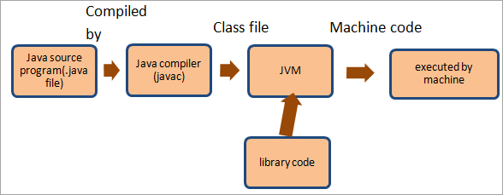

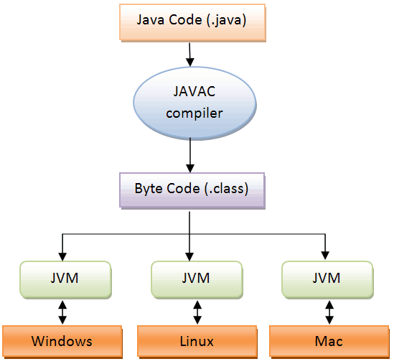

**Note- To run a class file, you need just JRE. But if you are a developer you need JDK.**

**JAVA RUNTIME ENVIRONMENT(JRE)-**

**JRE = JVM + set of libraries + other additional files to run applets and applications**

🡪JRE does not contain tools and utilities such as compilers and debuggers for developing applets and application.

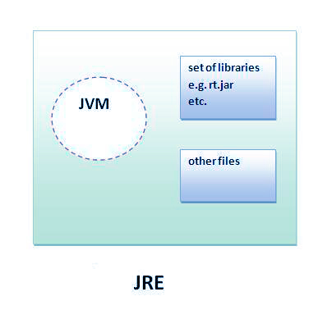

**JAVA DEVELOPMENT KIT (JDK)-**

**JDK = JRE + Development tools such as compilers or debuggers** (necessary for developing applets and applications)

OR

**JDK = (JVM + set of libraries + other additional files) + Development tools**

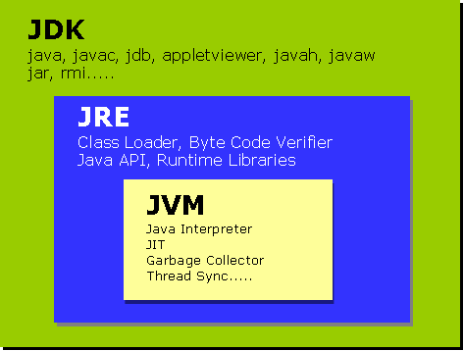

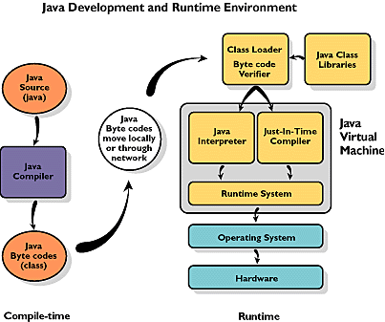

**-----------------------------------------------------------------------------------------------------------------------------------------**

**Topic to revise🡪**

**Modifiers:** 1) Access modifiers 🡪default (visible to the package), public(visible to the world), private(visible to the class only), protected(visible to the package and all sub classes)

2) Non-Access modifiers🡪 static, final, abstract, synchronized, and volatile

------------------------------------------------------------------------------------------------------------------------------------------

**Variables:** Variables are the memory location reserved to store values.

Types of variables->

1. **local**

🡪 Local variables are declared inside a method, constructor, or block.

🡪Local variables are created when execution enters a method constructor or block.

🡪Access modifiers cannot be used for local variables.

🡪A local variable is only accessible inside the declared method, constructor, or block.

🡪Local variables are implemented at stack level internally.

🡪There is no default value for local variables, so local variables must be declared, and initial values must be assigned before the first use.

**2)instance**

🡪 Instance variables are declared in a class**.**

🡪 When a space is allocated for an object in a heap, a slot for each instance variable value is created.

🡪Instance variables are created when an object is created and destroyed when the object is destroyed.

🡪Access modifiers can be given for instance variables.

🡪The Instance variables are visible for all methods, constructors or blocks in the class.

🡪Instance variables have default values. number:0, Boolean: false, Object Reference: null

🡪Values can be assigned during the declaration or within the constructor.

🡪Instance variables can be accessed **directly by calling the variable name** inside the class. However, within the static methods (when instance variables are given accessibility) they should be called using the fully qualified name.  **ObjectReference.VariableName**

**3)class /static**

🡪 Class variables are declared with the static keyword inside a class, but it is created outside a method, constructor, or block.

🡪Class variables are declared as constants i.e., variables never change from their initial value.

🡪Static variables are stored in static memory.

🡪it is rare to use static variables other than declared final and used as either public or private constants.

🡪Static variables are created when the program starts and destroyed when the program stops.

🡪Static variables are declared public since they must be available for users of the class.

🡪Static variables can be accessed by calling with the class name- **ClassName.VariableName**

**Data types:** Each variable in java has a specific type, which determines the size of the memory, the range of values that can be stored, and the set of operations that can be applied to the variable.

**1)Primitive data types:** predefined be the language and named as a keyword.

Syntax: int num= 50;

There are 8 major primitive data types:

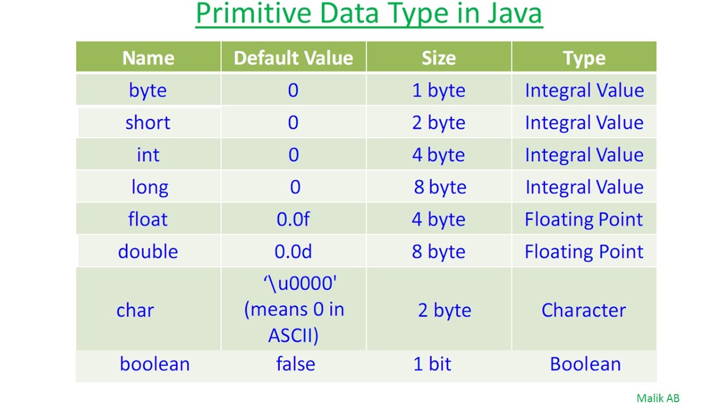

**2)Non-primitive(reference) data types:** created using defined constructors of the class.

Example: objects of various classes Strings and Arrays come under reference data type.

Syntax: Student s1=new Student();

🡪Reference variables hold bits that represents a way to access an object.

🡪It does not hold the object itself, but it holds a reference address to the object.

🡪reference type does not have size or bit range

**Data type conversions:**

The data type of a particular variables can be converted to other data types.

Requirement for this: To perform any operation we need both the variables to be of same data types.

There are two ways to perform datatype conversion:

**1)implicit:** avalue of one type can be changed to a value of another type without any special directive from the programmer.

**2)explicit: 🡪**explicit conversions are done by type casting.

🡪casting can be used to convert among any of the primitive types except Boolean.

Ex :

int i;

double d=45.5;

**int i= (int)d;**

//after type casting now i =45 && note: casting may loose information

Note: confusion in type conversion chart.

**Type conversion methods:**

String to int: Integer.parseInt() and Integer.valueOf()

int to String: Integer.toString() and String.valueOf()

**Operators:**

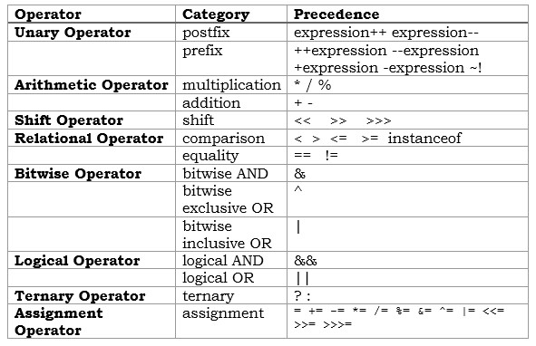

**Control statements:**

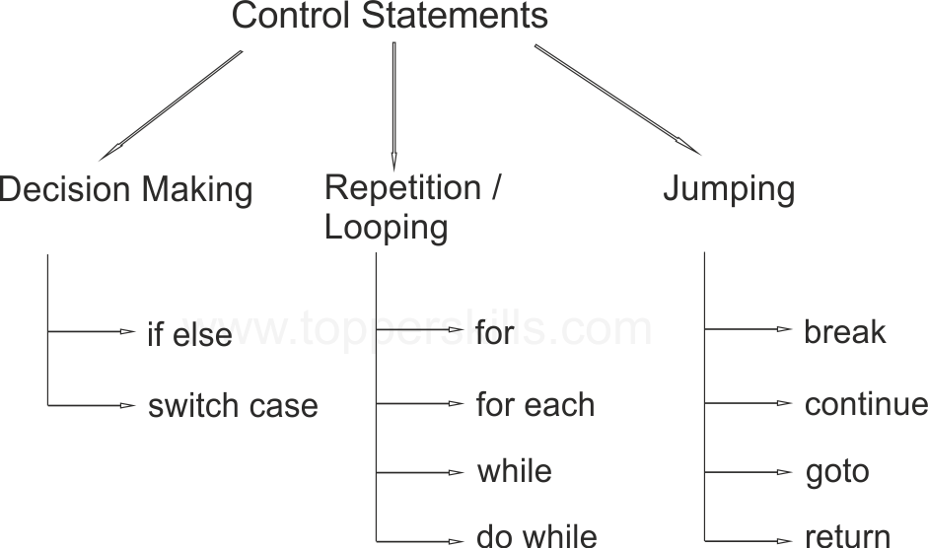

Methods🡪It defines the behavior of a class.

Ways of calling a method🡪

Call by value: Instead of passing the memory location it passes the value of a particular variable.

Method Overloading🡪 A class may define multiple methods with the same name and return type, but different number of arguments or arguments of different data types. This is called method overloading.

Array 🡪 An array is a group of like-typed variables, that are referred to by a common name.

Note 🡪Arrays are created either using new operator or array initializer.

Different ways of declaring arrays🡪

1. int a[]=new int[5];
2. int []b=new int[5];
3. int c[]={1,2,3,4,5};
4. Int []d=new int[] {1,2,3,4,5};

Note 🡪 we can check the length of any array by using length function.

int x[]=new int[20];

System.out.println{x.length}; here20 will be output.

Types of array🡪

1)Single dimensional array

2)Multi-dimensional array

Int[][] a= new int[5][3] it means 5 rows and 3 column

**STRINGS🡪** Strings are used to store character array, but the array will be **immutable** in Strings.

🡪java String is a sequence of characters.

🡪They are objects of type string class.

🡪Once a string object is created, it cannot be changed. Strings are immutable.

**Different ways of creating a String: -**

1. String str=new String(); //using new keyword
2. String str1=”abcdef”; //using literals

**Java Strings are immutable for several reasons:**

Security- Strings are used for network connection and for database connection. To avoid the access to these connections from external users, Strings are immutable.

Synchronization- immutability of Strings automatically makes system **thread safe** to solve the Synchronization problem.

Caching-If multiple Strings are having the same value, it will not create multiple copies of it. There would be just one value in the string pool, which would be accessed by all the references.

**String pool**

**🡪**it is a pool of strings stored in Java Heap Memory.

🡪It helps in saving lot of space for java run time.

🡪The string pool can contain multiple Strings, but the heap memory can have only one string pool.

Note 🡪We have heap memory where the objects are created, and string pool resides as well.

Note 🡪Strings are immutable. If you change it, you cannot change that memory location. It creates one more entry in “string pool”, and the reference would point to the new entry. So, the actual memory location is not getting changed, that is what immutability is all about.

**Strings- Memory Allocation**

🡪The String is not a primitive data type.

🡪String is the wrapper class to array of characters.

🡪The java Strings are stored in the String Pool of the Heap area.

🡪When we create object of String, then object name(variable) will be stored in Stack portion of memory and the value we are assigning to that variable will be stored in String Pool(portion of heap memory).

String s= ”HELLO”;

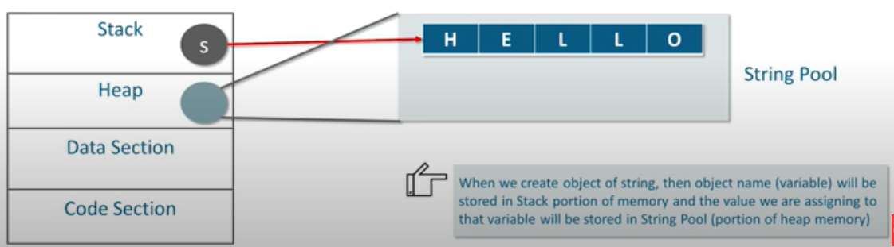

Note🡪when we have a local variable, the reference is created in the stack and the actual object is created in the heap.

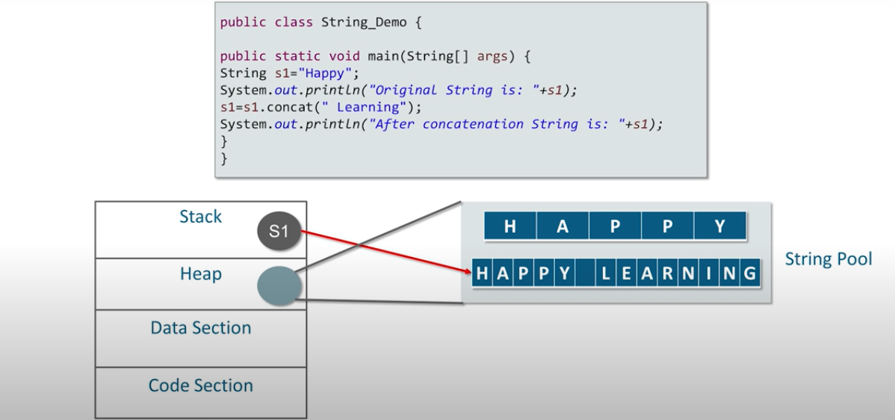

**String operations**

String s=”jyotsana”;

int a=50;

1. s.length(); //8
2. s.substring(2); //otsana
3. s.isEmpty(); //checks the string is empty or not
4. s1.compareTo(s2); //this method ignores case
5. s.toLowerCase();
6. s.toUpperCase();
7. valueOf(a); //converts different data types into string
8. s.replace(‘a’ , ‘i’); //replace all ‘a’ with ‘i’
9. s.contains(“j”); //true
10. s1.equals(s2); //compares two strings on the basis of the content of the string. Case sensitive
11. s.charAt(3); //returns the character at given index ans is ‘t’
12. s.endsWith(“a”) //true

**Variants of String:**

**1)String**🡪 Strings are immutable.

🡪we do not have methods to manipulate the string.

**2)StringBuffer**🡪Java StringBuffer is used to create mutable String i.e. memory allocated to the string is not fixed. It can change.

🡪It is synchronous (there is only one tread that can access the string at one time) in nature i.e. thread safe. Note -Synchronization makes it slower and lower in performance.

🡪Its good to use StringBuffer when there are multiple threads accessing and modifying the string.

🡪We have methods to manipulate the string. Example append() , insert()

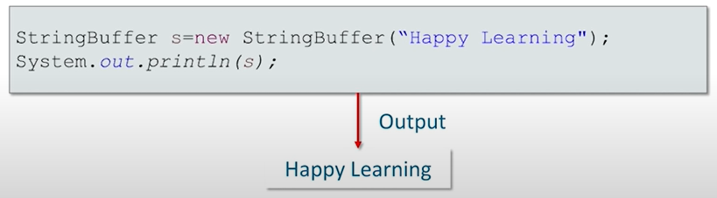

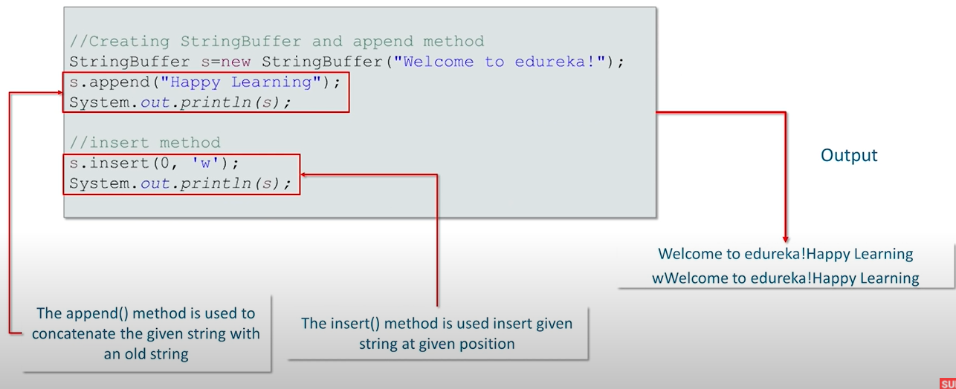

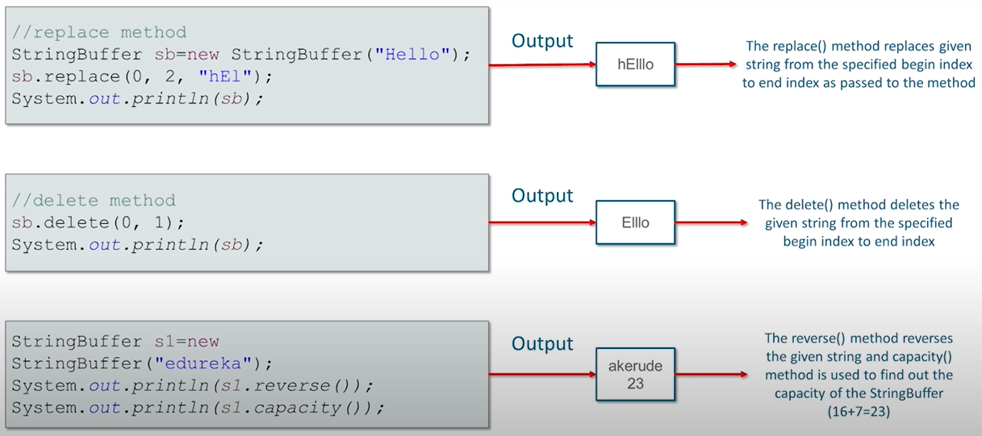

**3)StringBuilder**

🡪The Java StringBuilder class is used to create mutable string.

🡪But StringBuilder class is non-synchronized i.e. It is not thread safe. therefor

StringBuilder is faster.

🡪It is good to use StringBuilder, when it is a single threaded application.

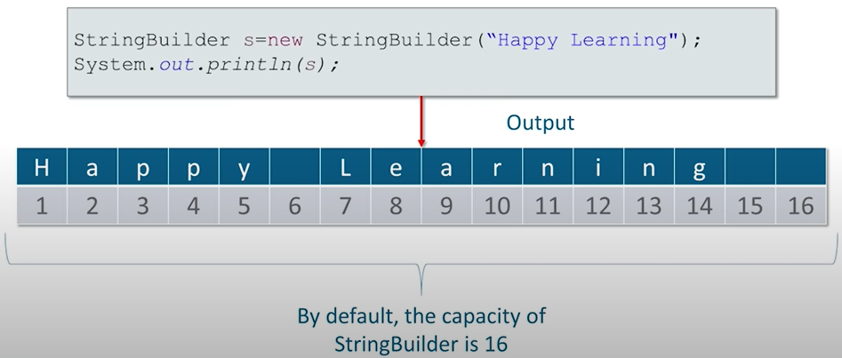

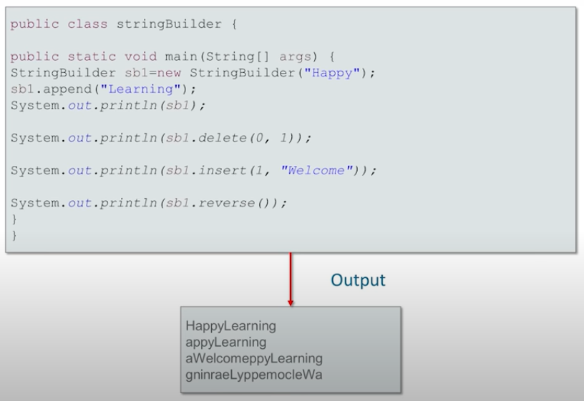

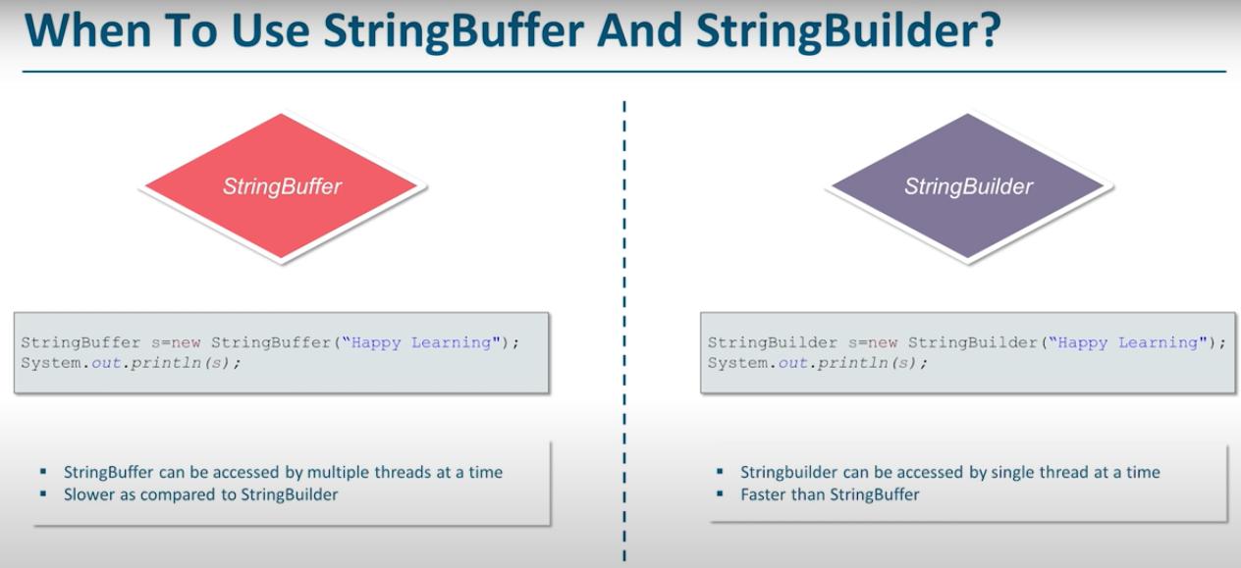

**Classes and Objects**

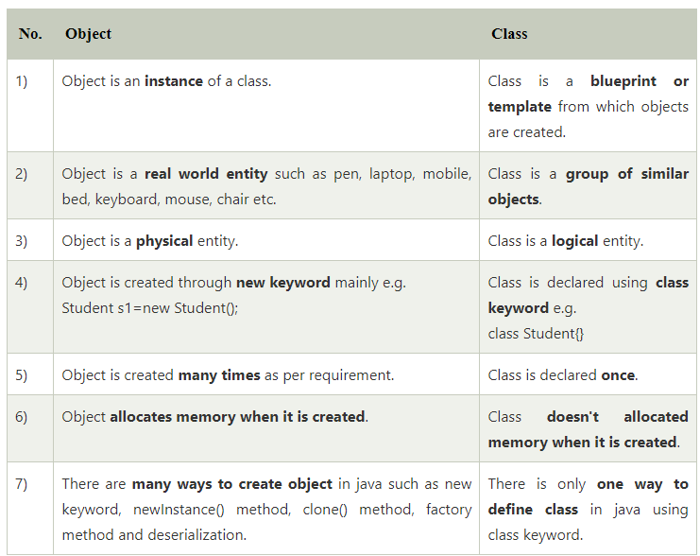

🡺Attributes=properties=instance variable=state

🡪method= behavior

Every class has state and behavior.

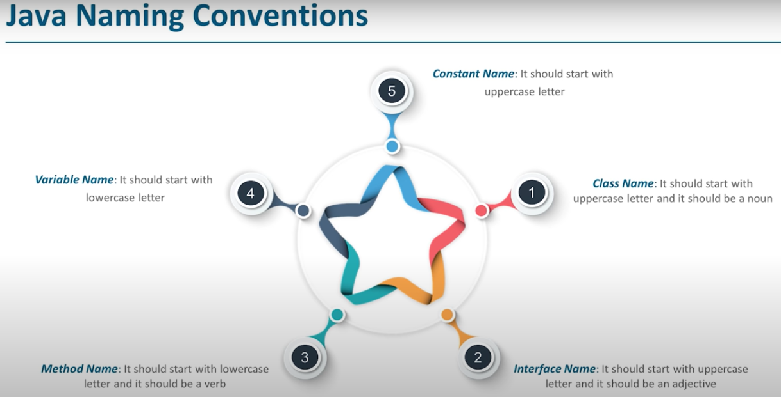

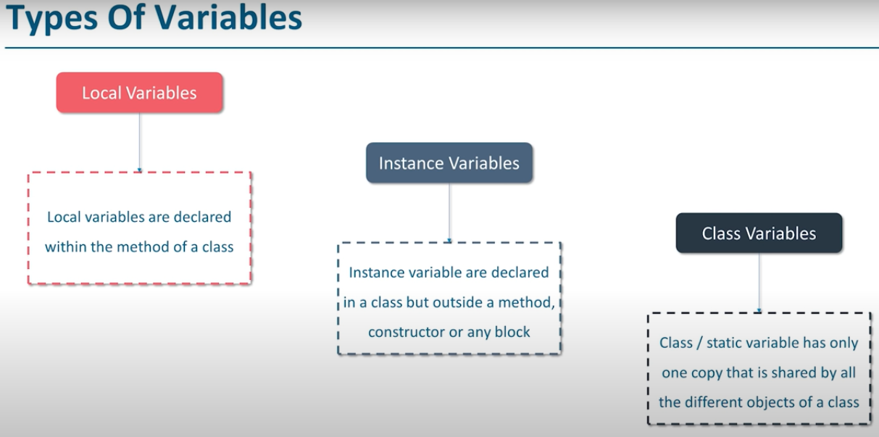

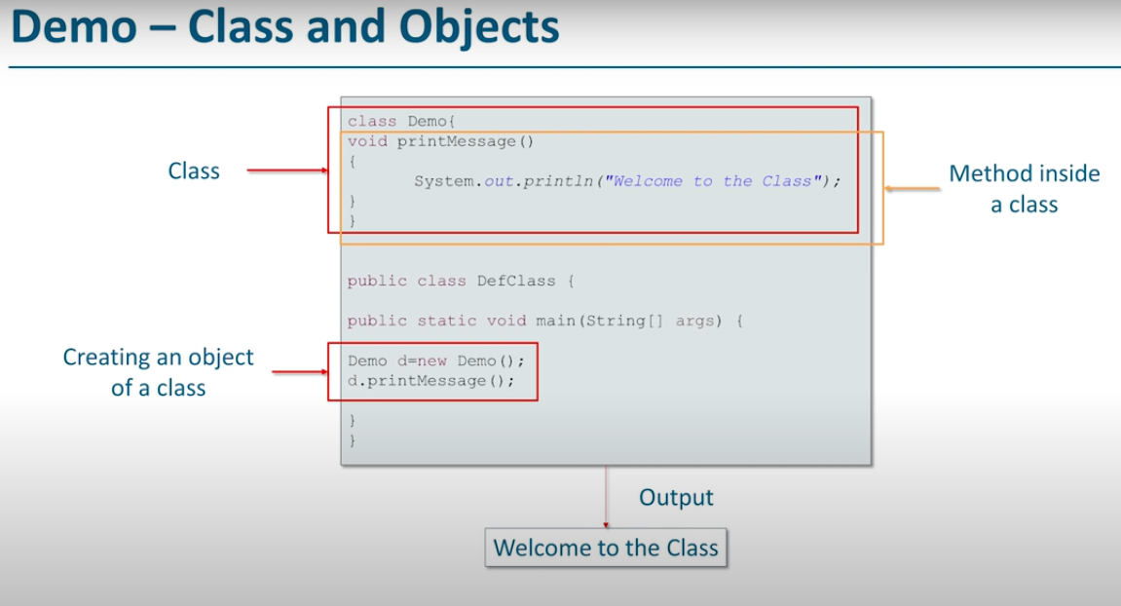

**Constructor**

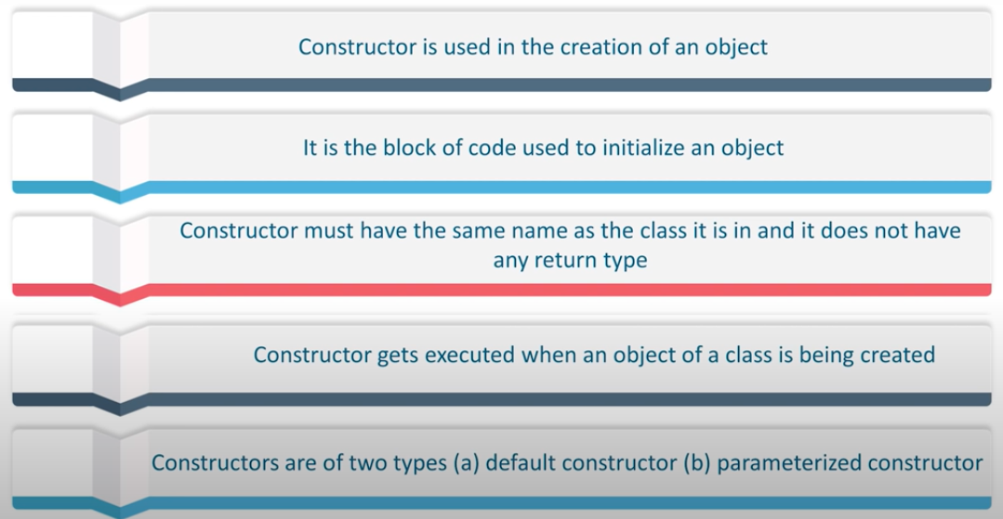

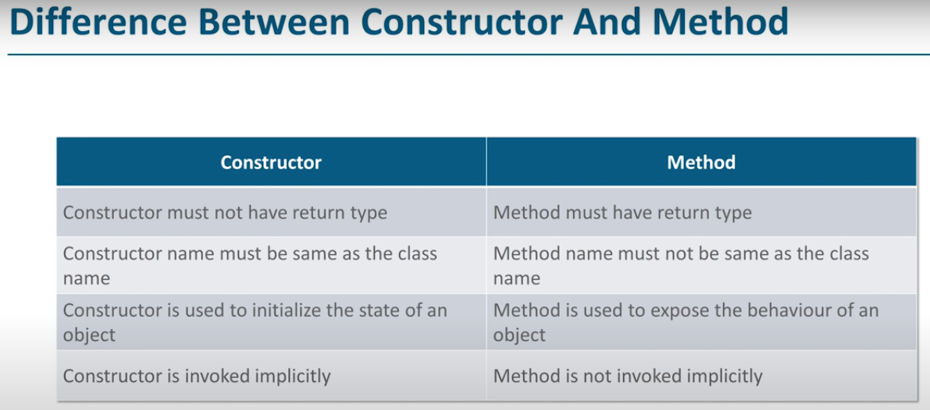

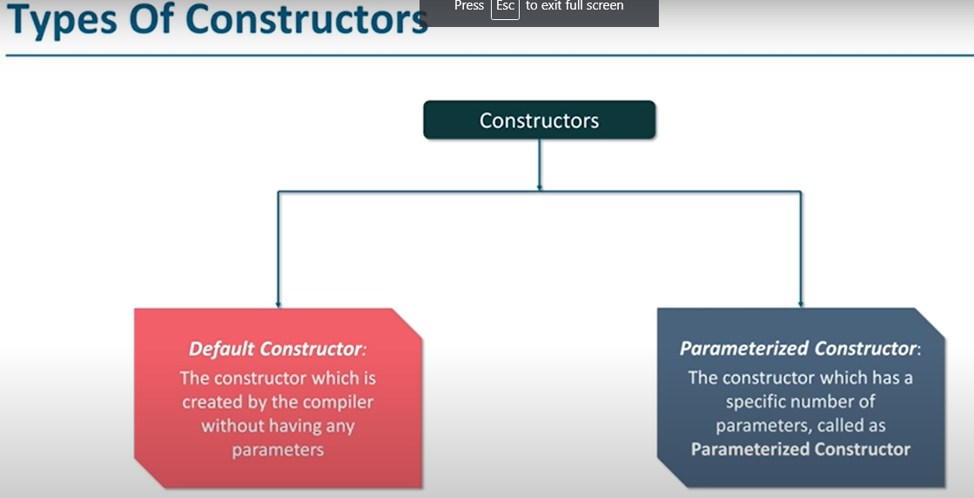

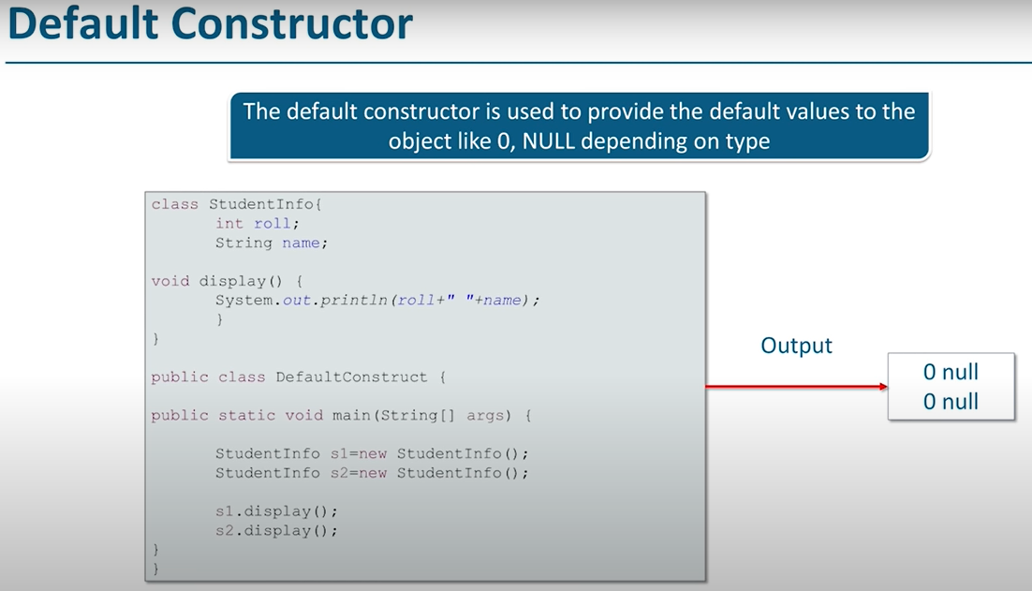

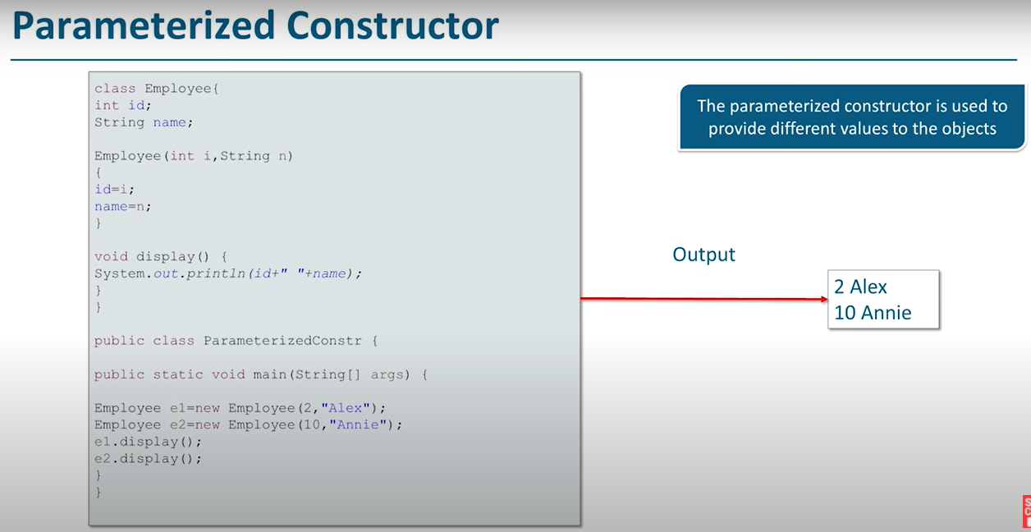

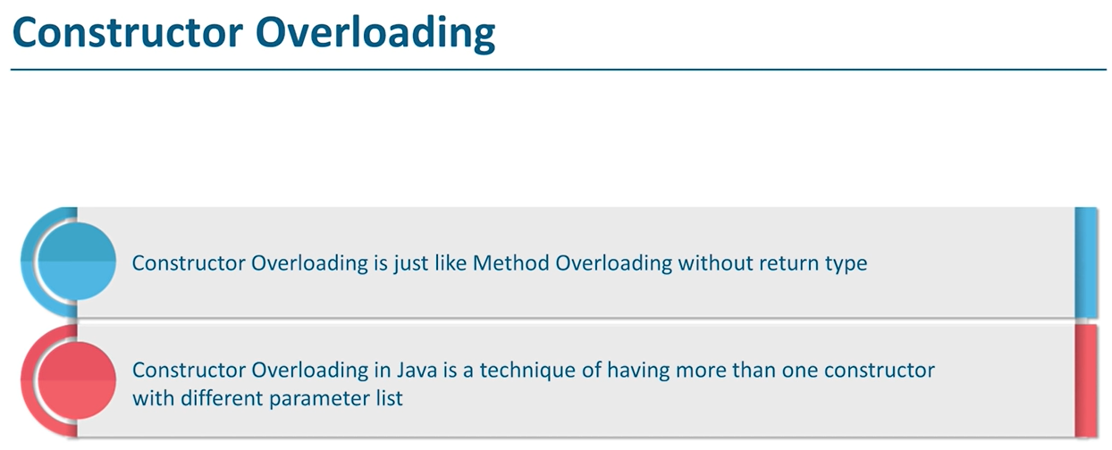

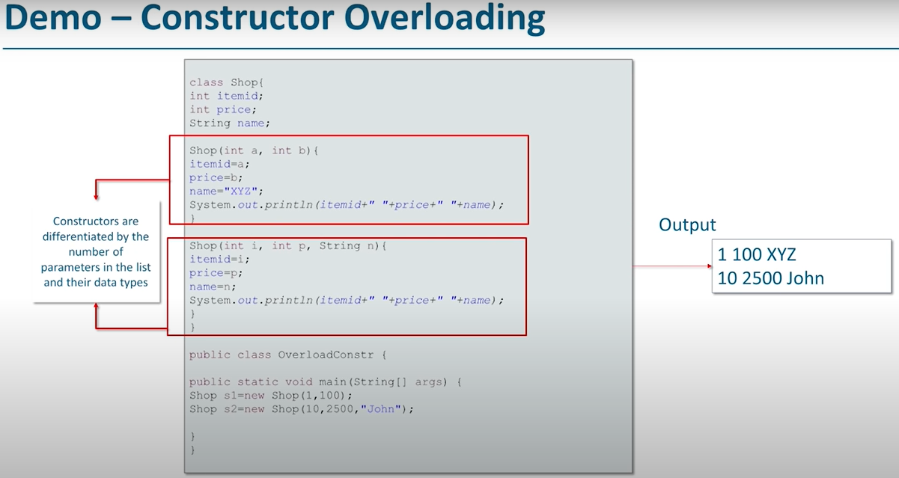

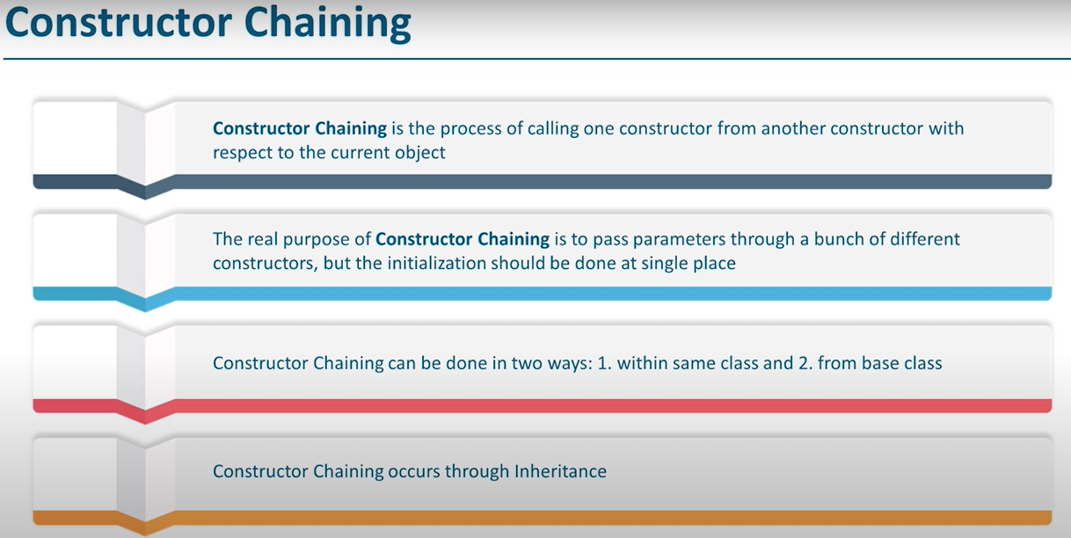

**Note🡪**Construction chaining can be done using two keywords:

1)this

2)super

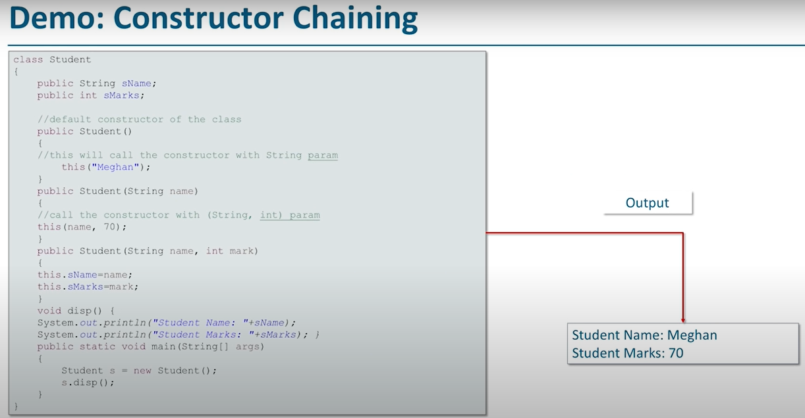

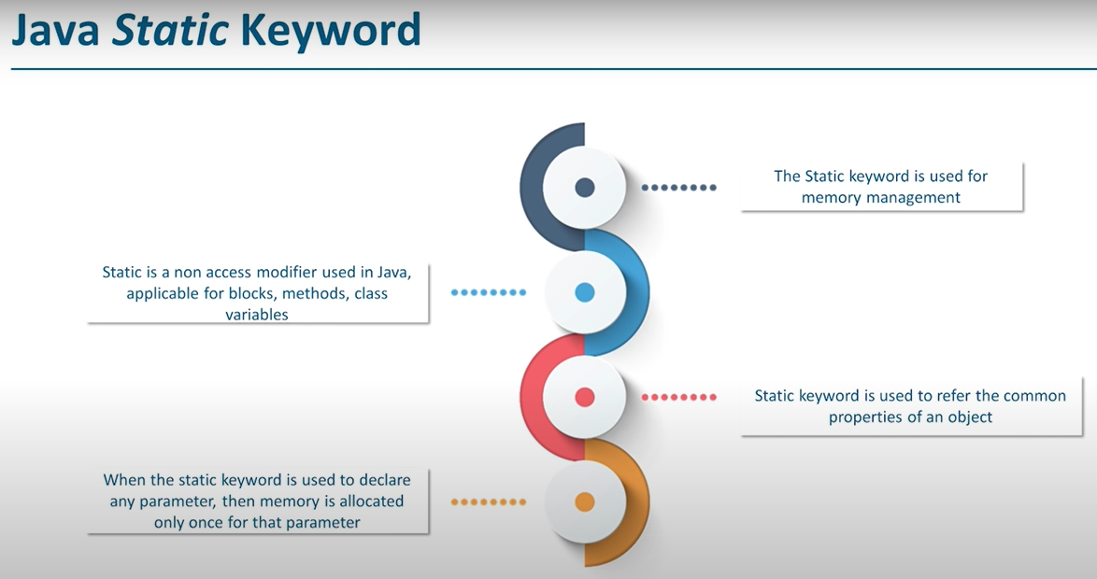

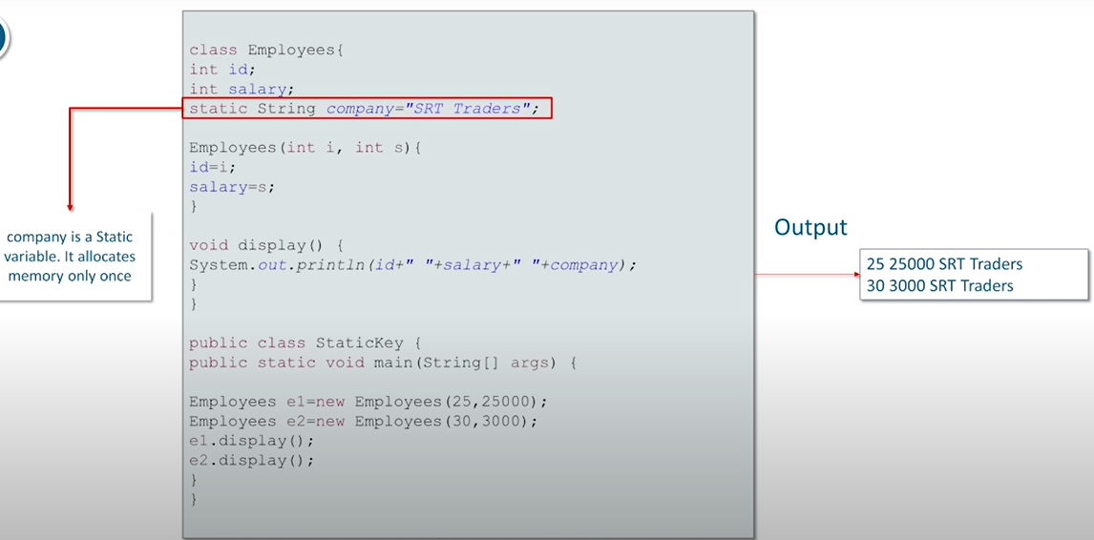

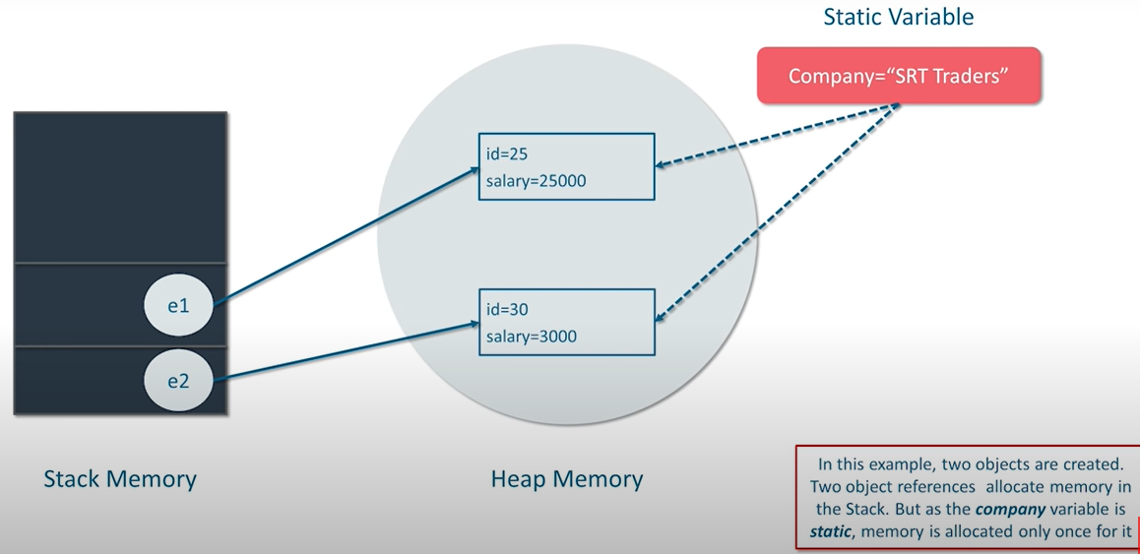

**Note** 🡪static variables are stored in a different space, previously it was permanent generation memory. But from Java 8 onwards the PermGen Space have been removed and new space named as MetaSpace is introduced which is not the part of Heap.

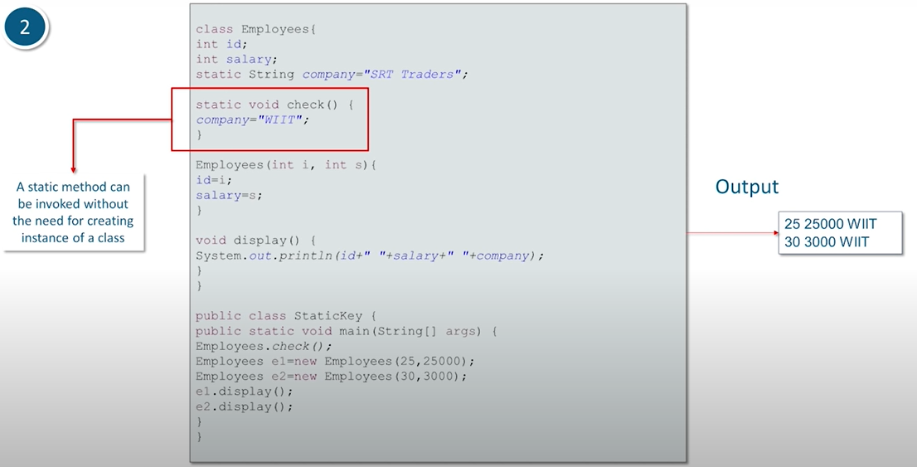

**this keyword**

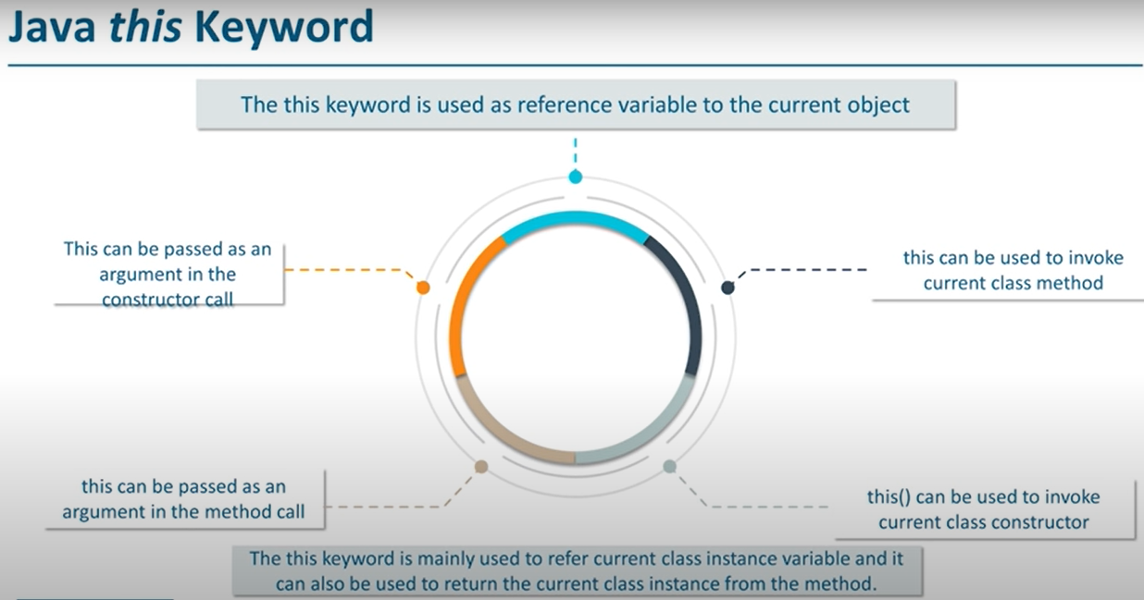

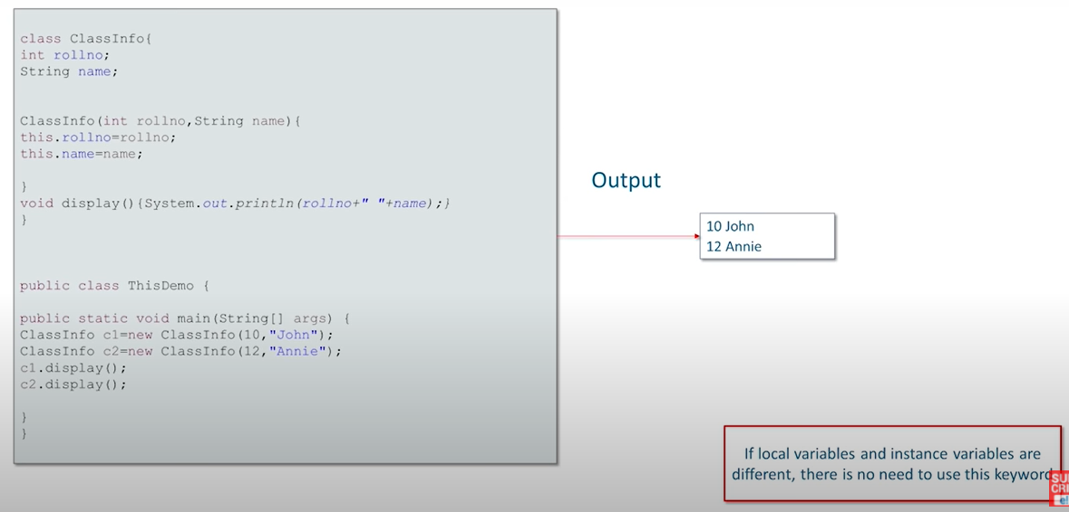

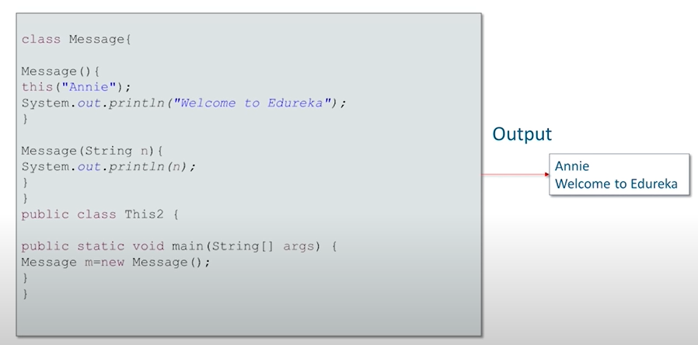

**From w3schools🡪s**

Definition and Usage

The this keyword refers to the current object in a method or constructor.

The most common use of the this keyword is to eliminate the confusion between class attributes and parameters with the same name (because a class attribute is shadowed by a method or constructor parameter). If you omit the keyword in the example above, the output would be "0" instead of "5".

this can also be used to:

* Invoke current class constructor
* Invoke current class method
* Return the current class object
* Pass an argument in the method call
* Pass an argument in the constructor call

**Object oriented programming concepts**

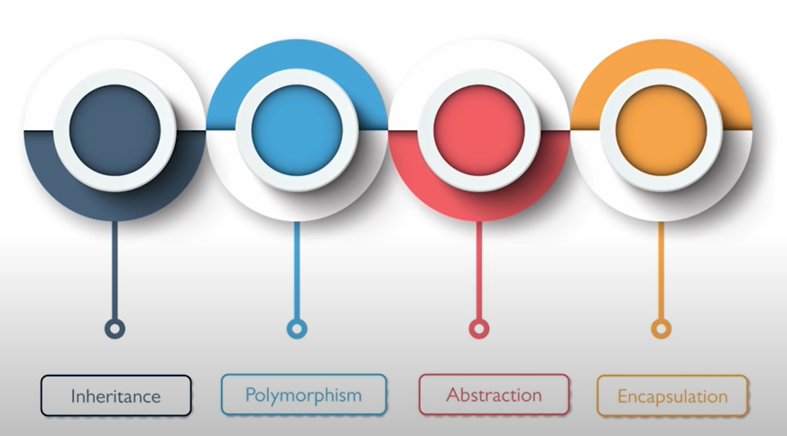

**1.Inheritance(IS-A relationship)🡪**

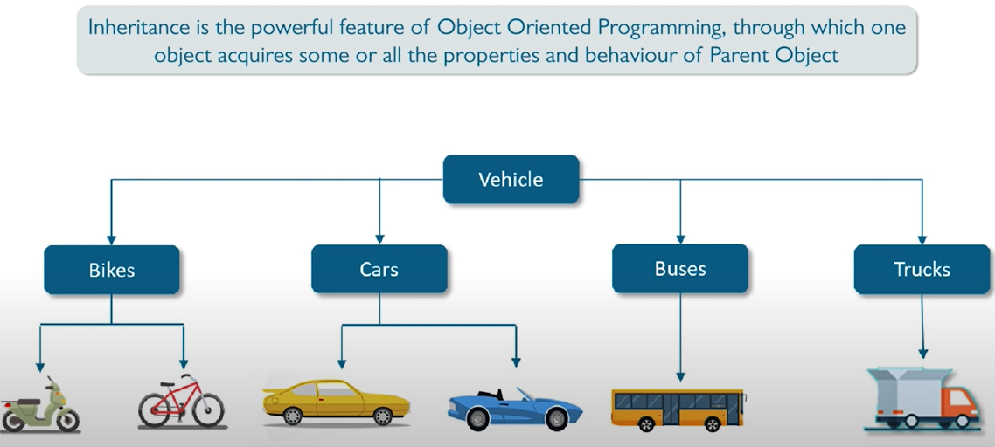

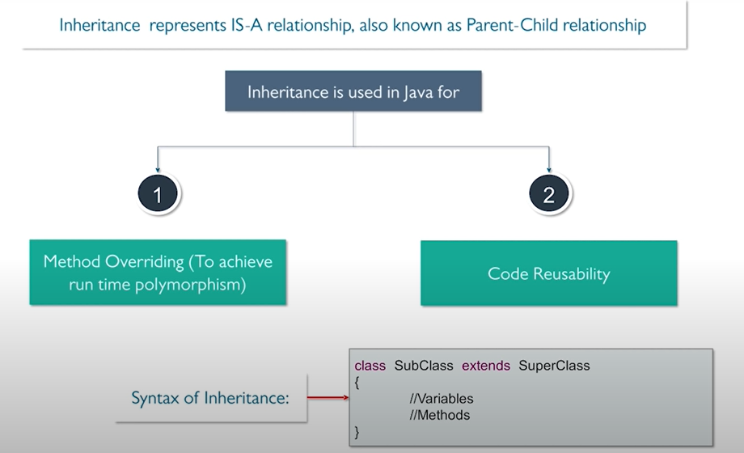

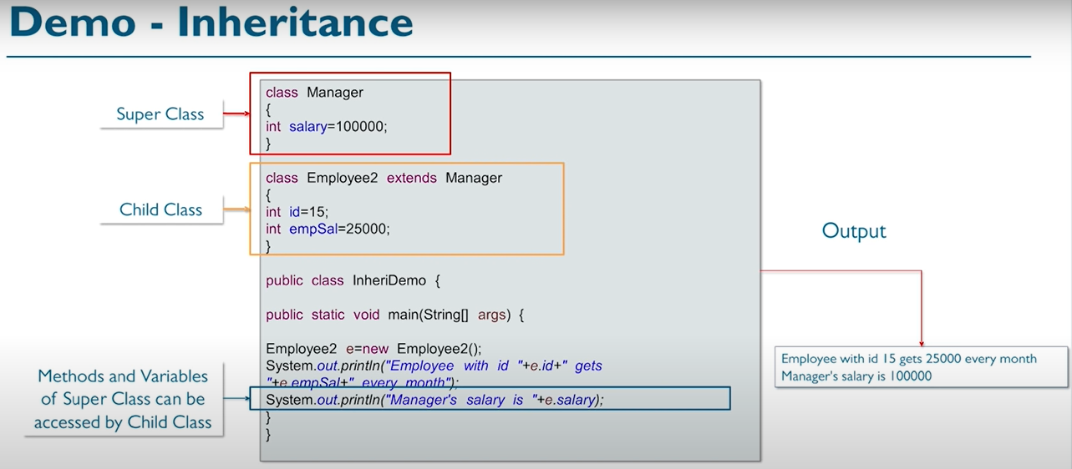

Types of Inheritance🡪

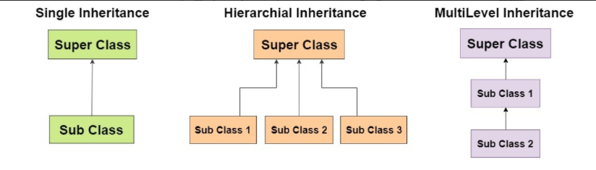

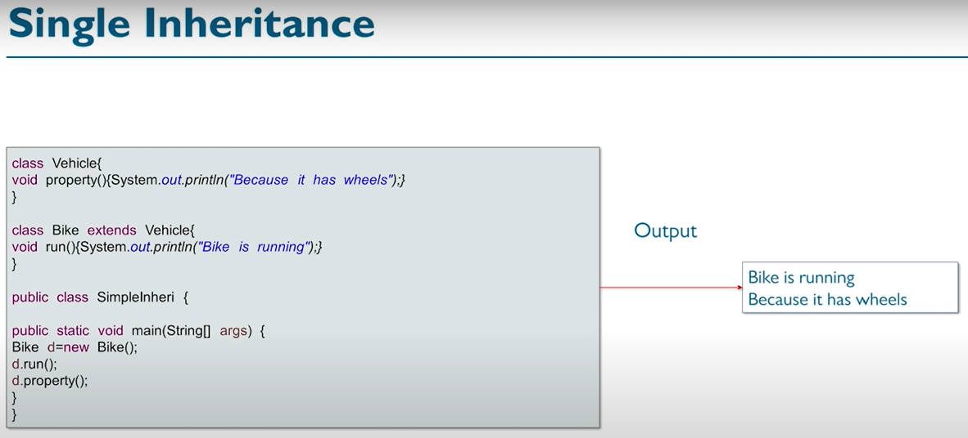

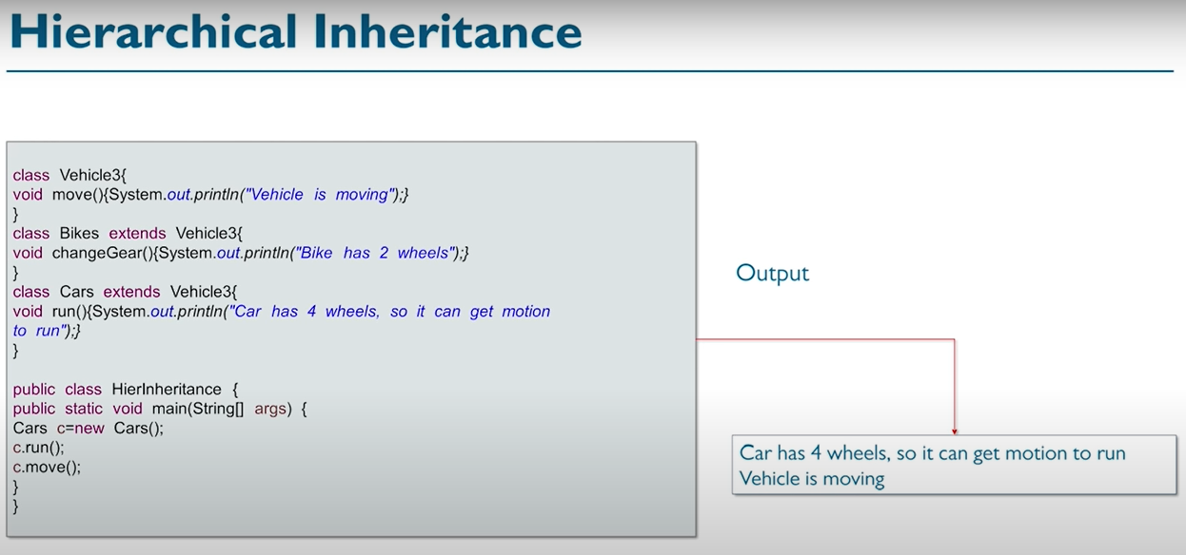

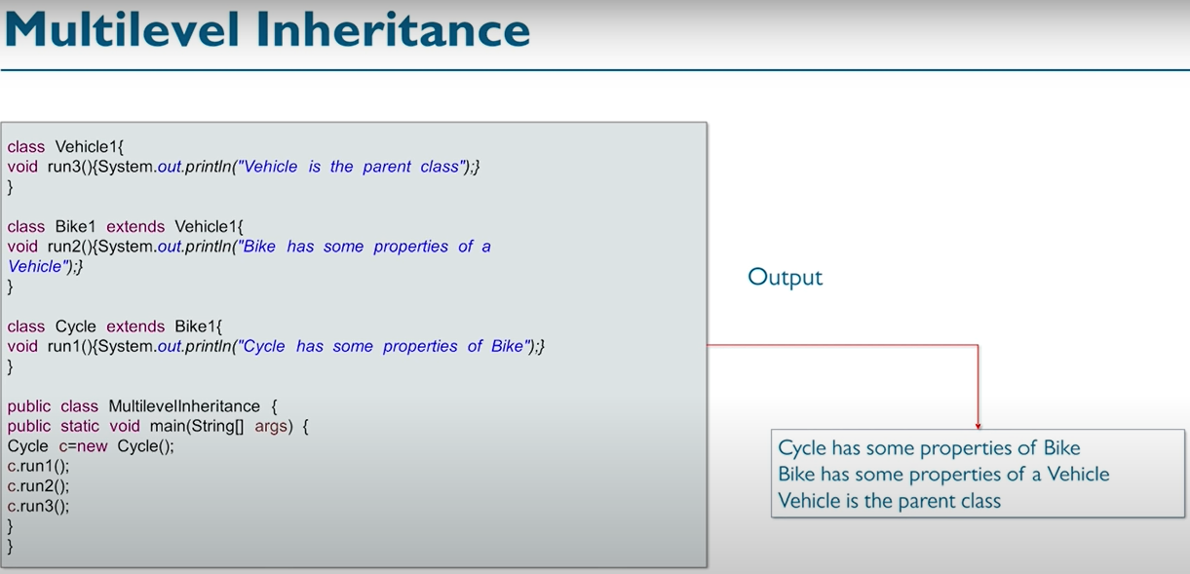

HAS-A Relationship🡪

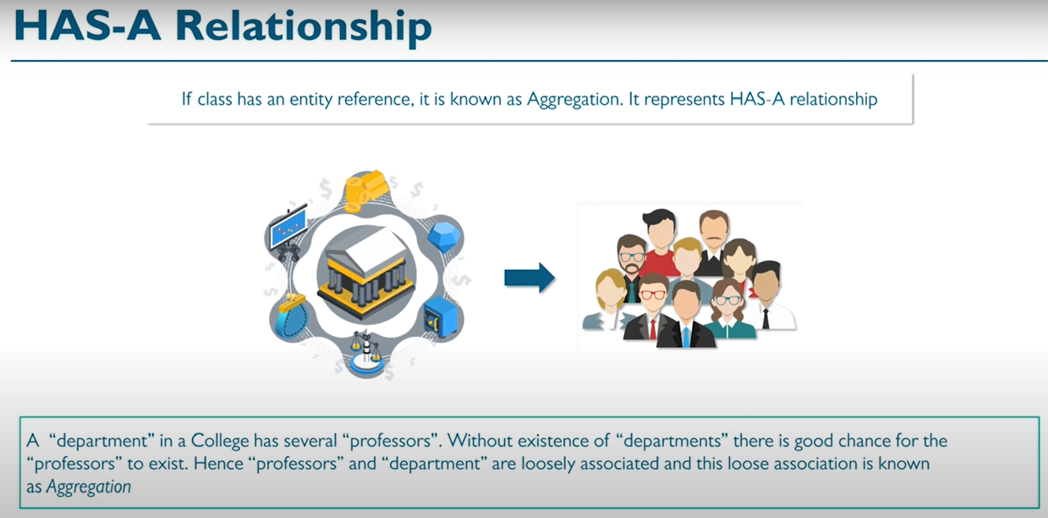

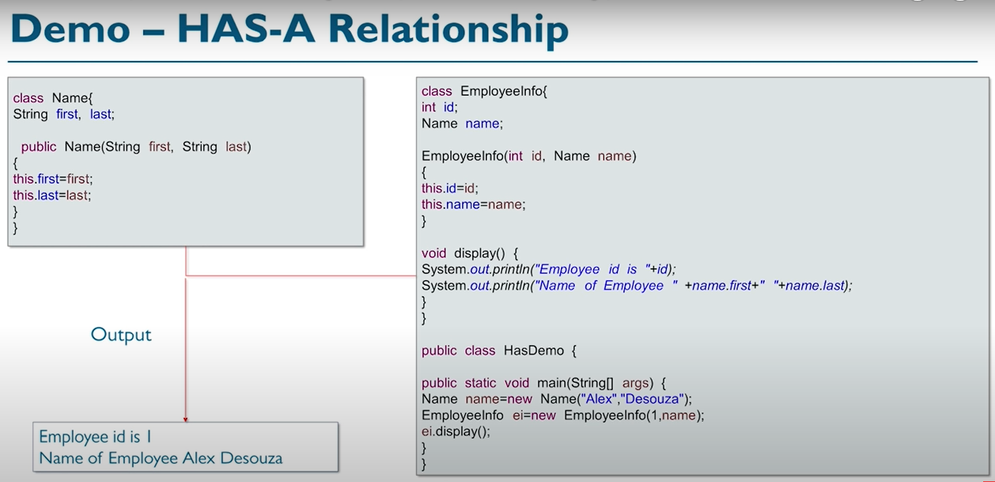

Note🡪 Using ClassA as a property in a ClassB. In the above example class Name is being used as a property in class EmployeeInfo.

And this class Name can be used somewhere else also other than EmployeeInfo. That’s why it is loosely coupled.

So this is aggregation. Name in Employee info is an object being used as a property but instead of name we can have a simple data type property as well.

**Important Notes**🡪  aggregation and composition are both subsets of association.

 In both aggregation and composition, an object of one class can be the owner of an object of another class.

 in an aggregation relationship, the life cycles of parent objects and child objects are independent. In a composition relationship, the death of a parent object also means the death of its children.

 1)**An association** is a “using” relationship between two or more objects in which the objects have their own lifetime and there is no owner.

As an example, imagine the relationship between a doctor and a patient. A doctor can be associated with multiple patients. At the same time, one patient can visit multiple doctors for treatment or consultation. Each of these objects has its own life cycle and there is no “owner” or parent. The objects that are part of the association relationship can be created and destroyed independently.

**2)Aggregation(HAS-A Relationship)** is a specialized form of association between two or more objects in which each object has its own life cycle but there exists an ownership as well.

An essential property of an aggregation relationship is that the whole or parent (i.e. the owner) can exist without the part or child and vice versa.

**3) Composition(PART-OF Relationship )** is a specialized form of aggregation. In composition, if the parent object is destroyed, then the child objects also cease to exist. Composition is actually a strong type of aggregation and is sometimes referred to as a “death” relationship. As an example, a house may be composed of one or more rooms. If the house is destroyed, then all of the rooms that are part of the house are also destroyed.

**2)POLYMORPHISM**🡪

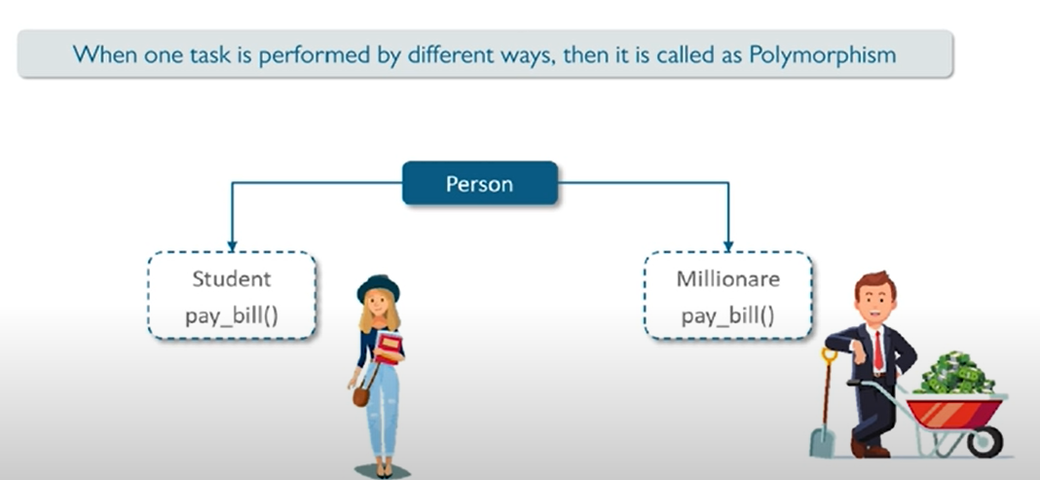

**1)STATIC POLYMORPHISM**/ compile time polymorphism (using method overloading)

**2)DYNAMIC POLYMORPHISM** (dynamic binding)/run time polymorphism (using method overriding)

Note 🡪Generally overloading will not be considered as polymorphism.



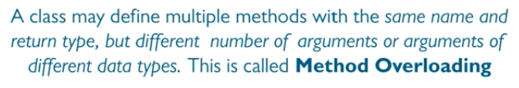

Note🡪 return type is not taken into consideration when we talk about method overloading. Only parameters are considered.

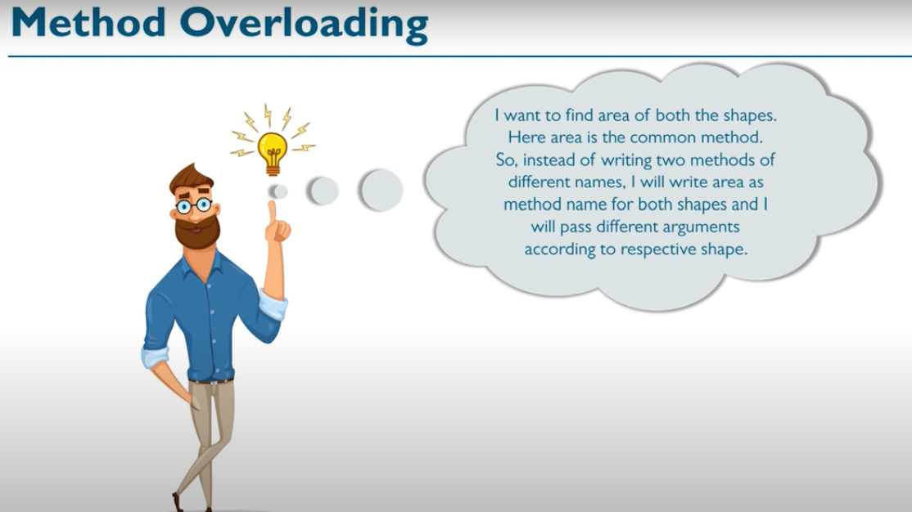

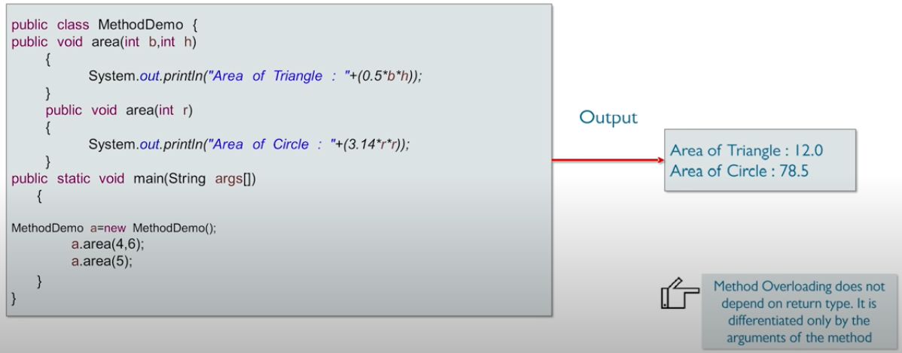

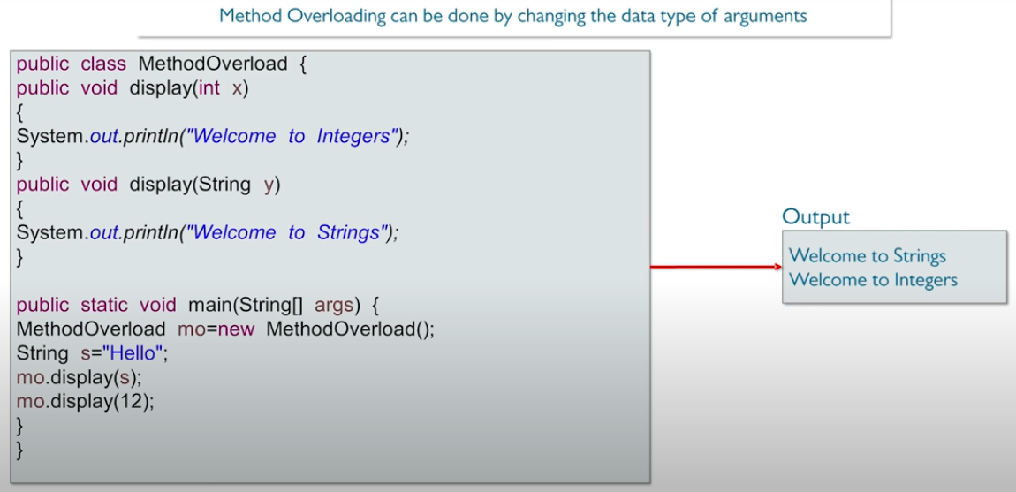

**Method Overriding: Run-Time**

**Polymorphism**

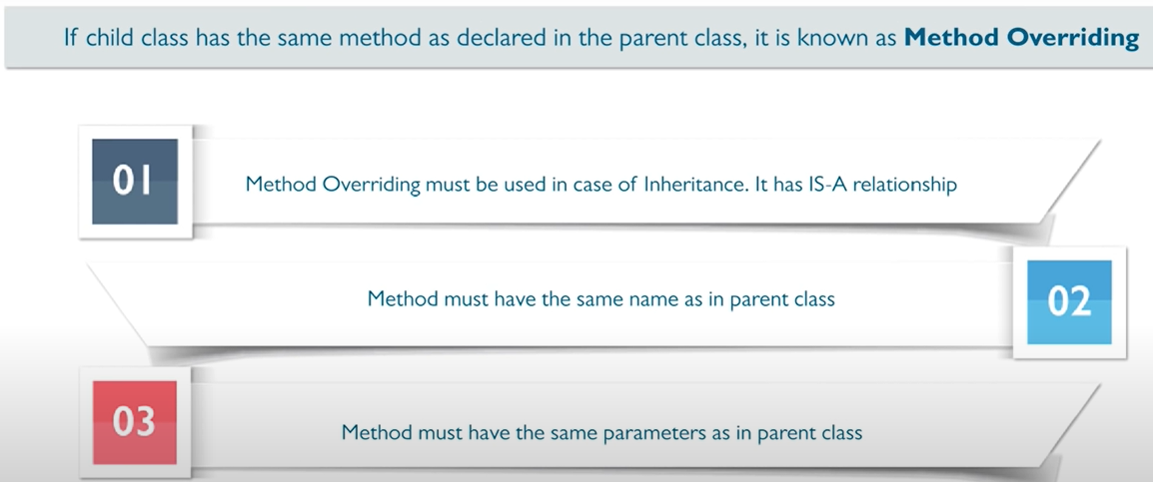

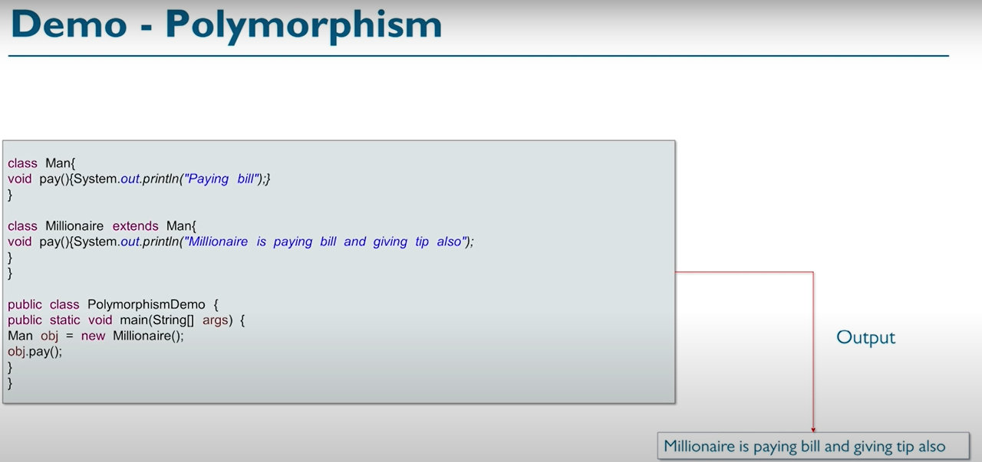

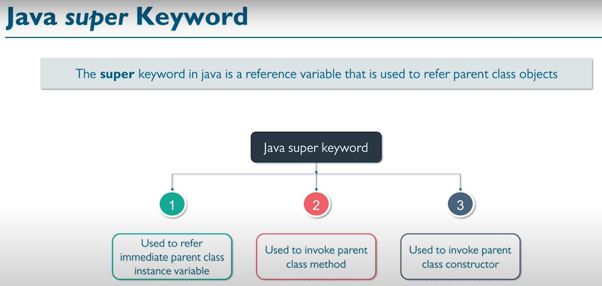

**Note🡪**super is called on the immediate parent class.

🡪When we call the constructor of a class, then JVM would call the constructor of the super class by default.

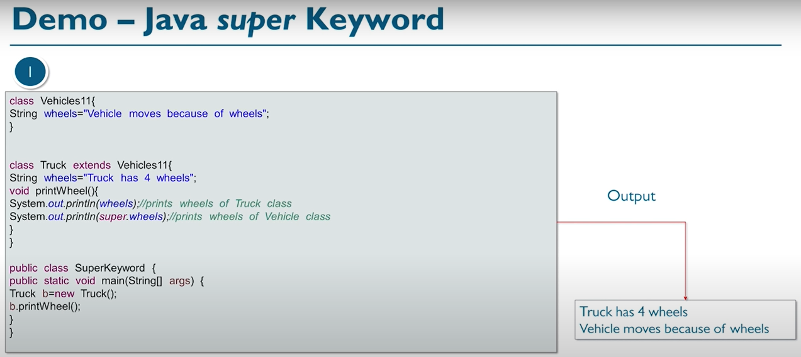

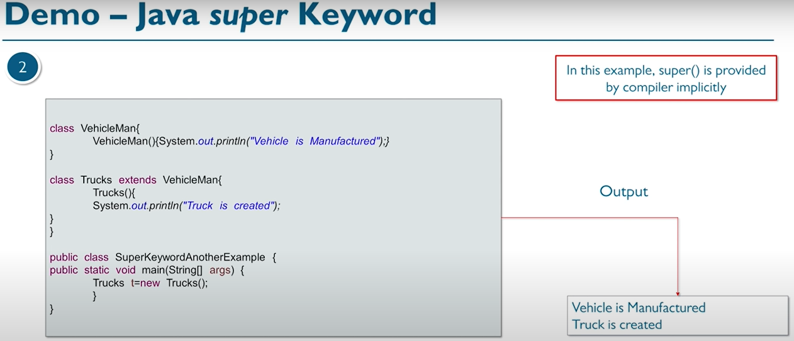

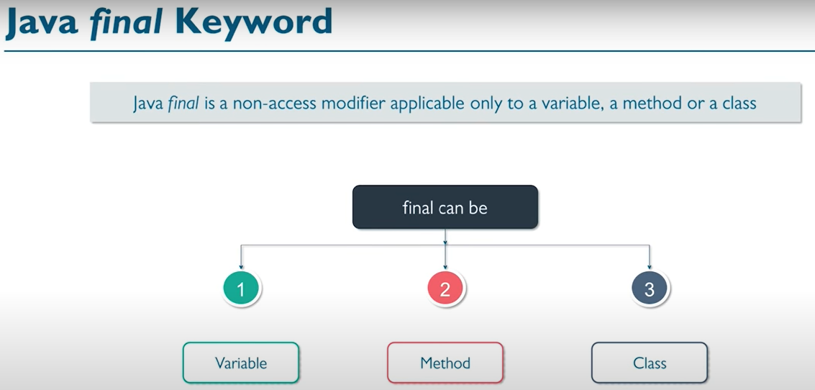

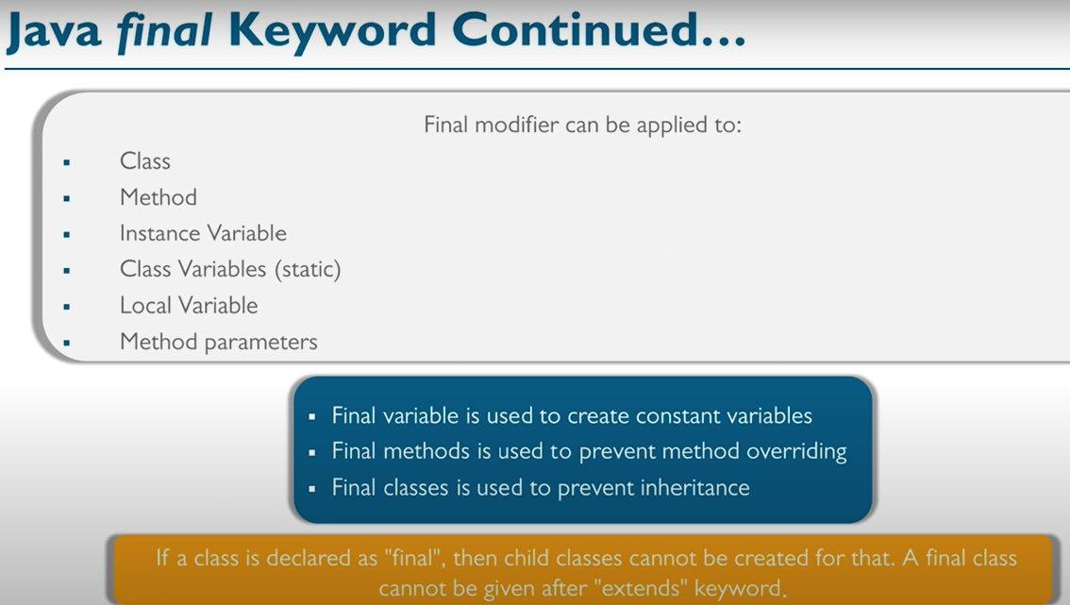

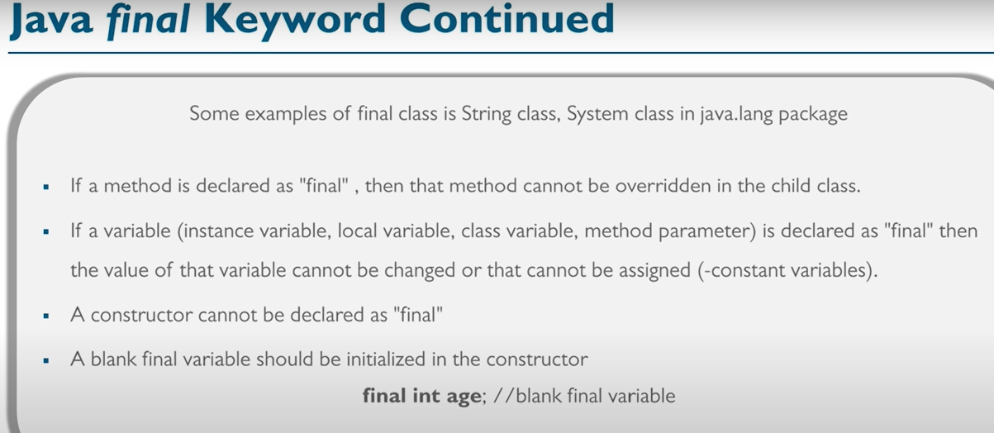

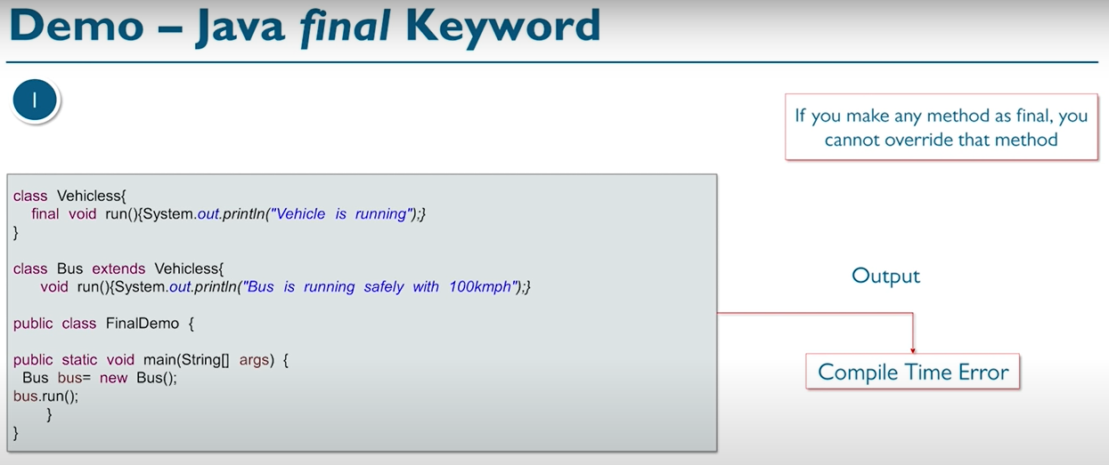

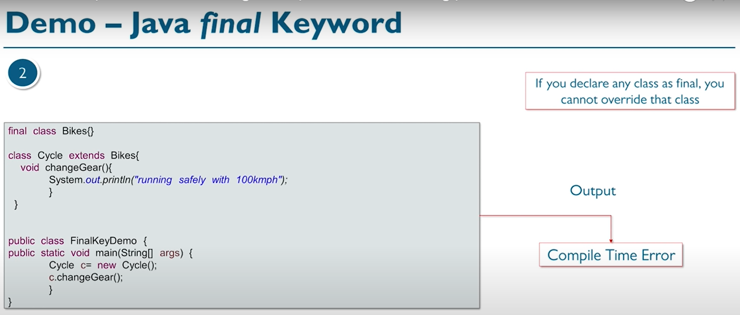

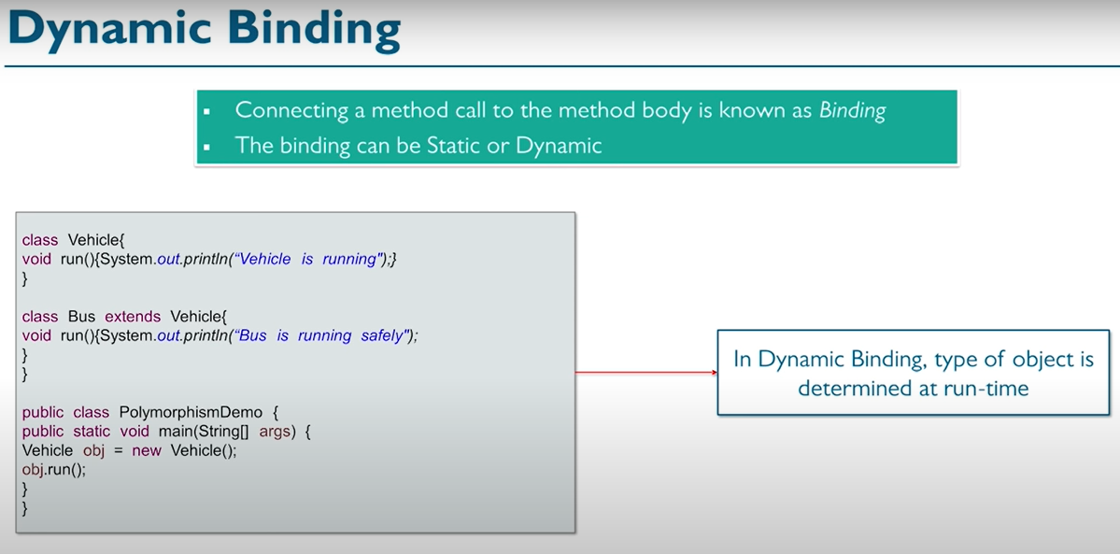

Note🡪In the case of inheritance and method overriding, which method will be called is decided at run time. that’s why dynamic binding is also known as run time polymorphism. (when object of subclass is assigned to the reference of super class type.)

**ABSTRACTION🡪**

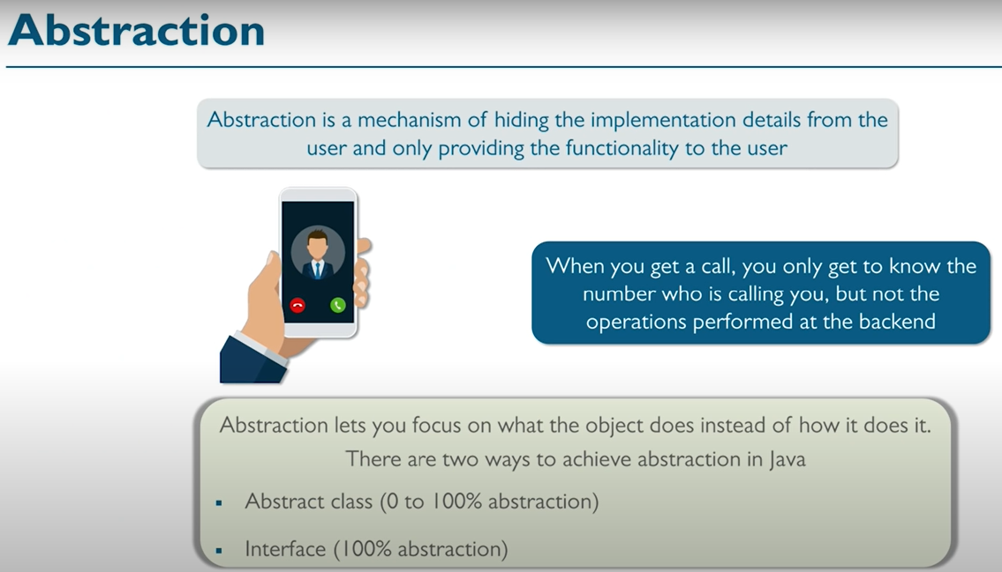

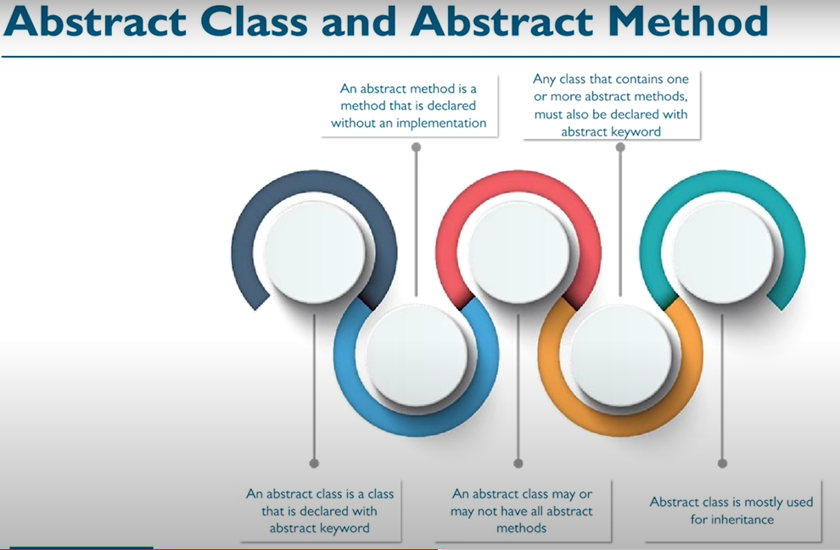

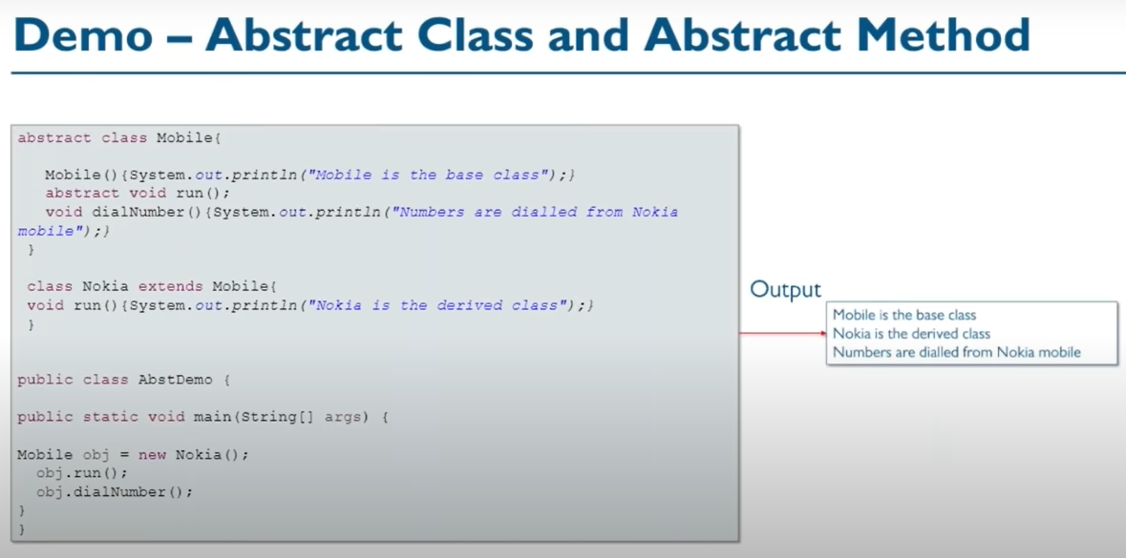

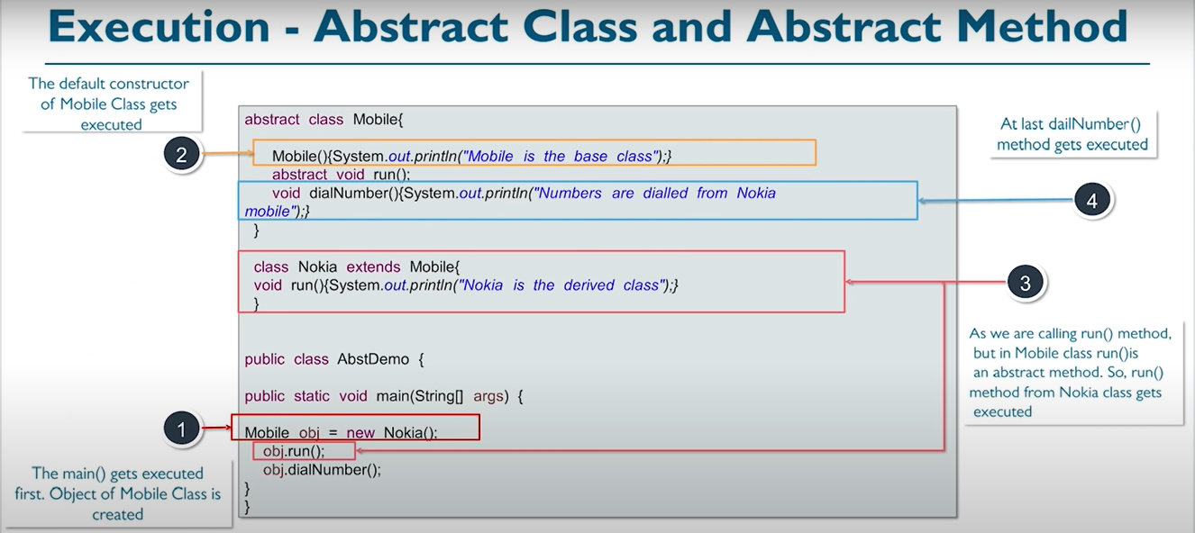

**IMPORTANT NOTE** 🡪When an abstract class is subclassed, the subclass usually provides implementations for all of the abstract methods in its parent class. However, if it does not, then the subclass must also be declared abstract.

**ENCAPSULATION🡪**

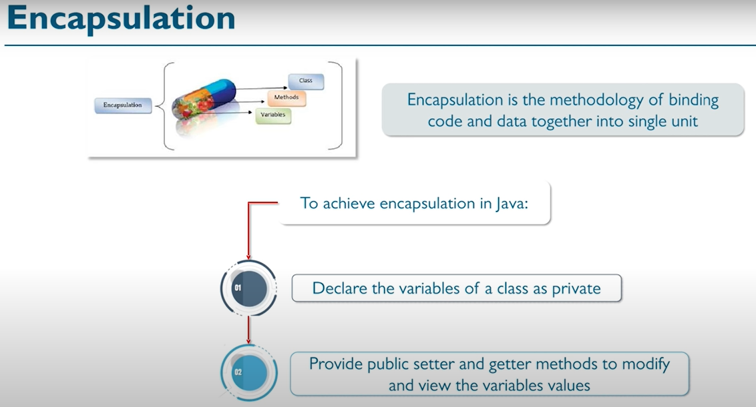

NOTE🡪It is good practice to restrain visibility as much as possible. More public variables increases the maintenance of the application.

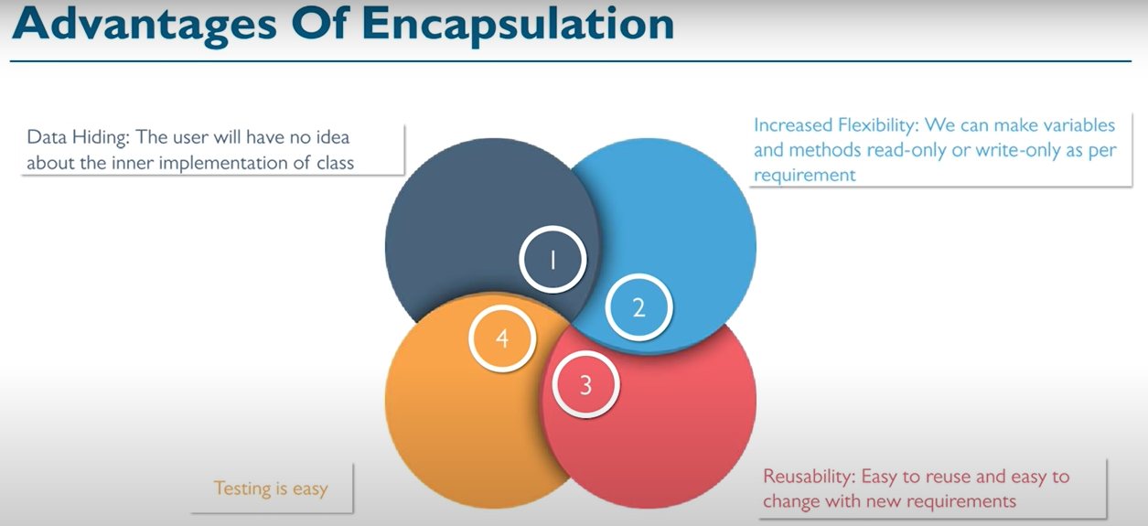

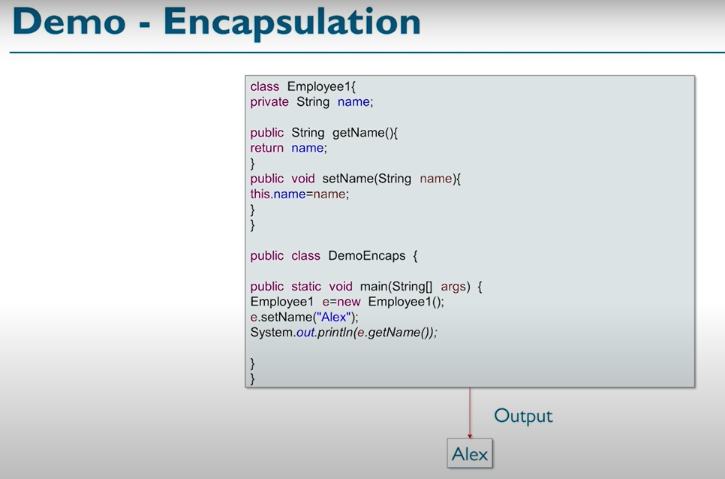

**INTERFACE🡪**

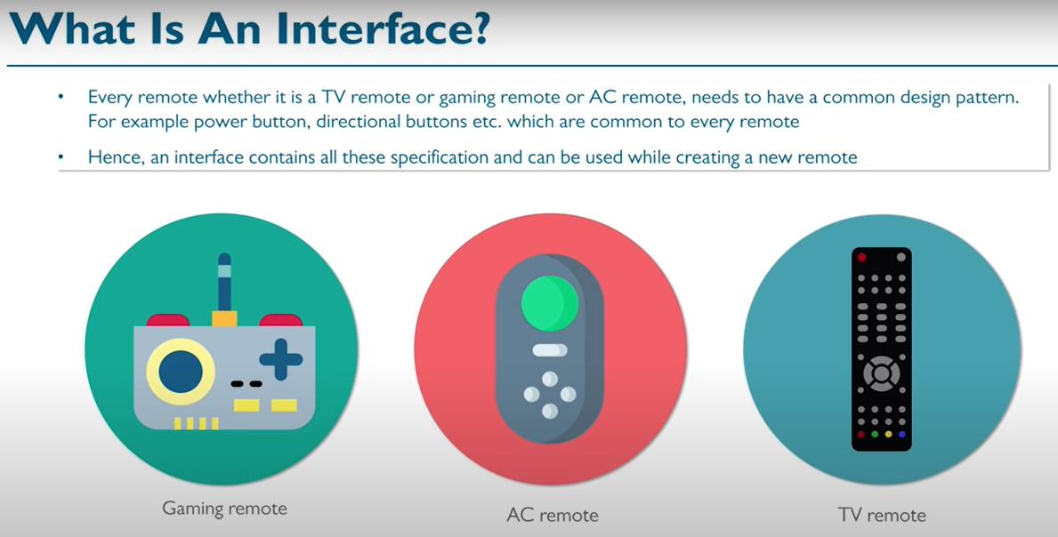

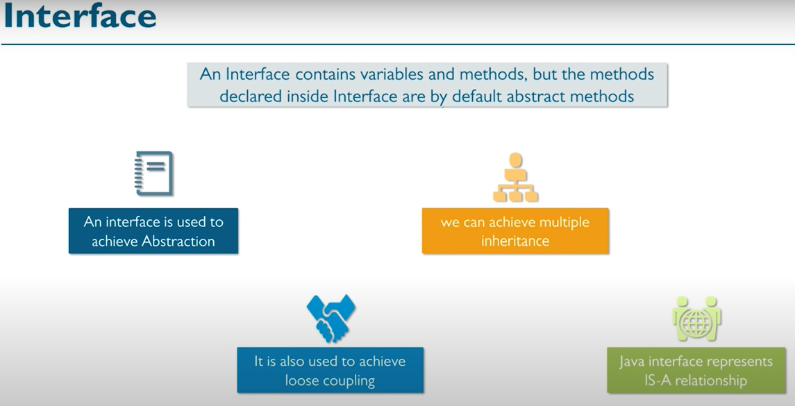

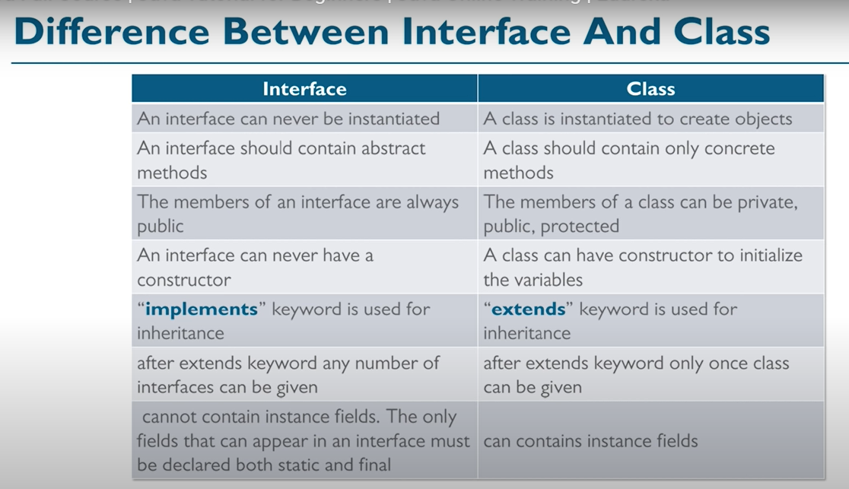

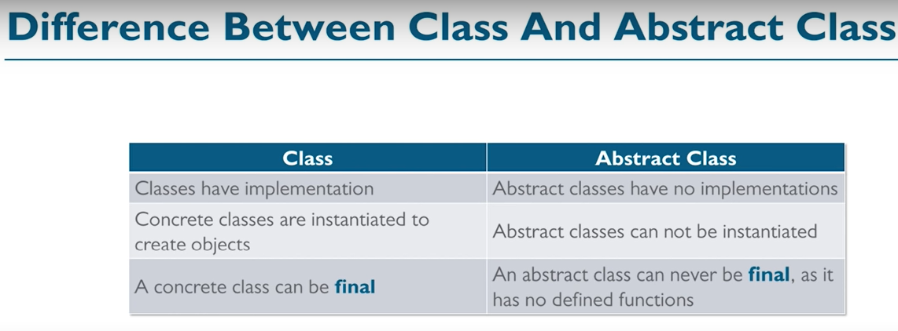

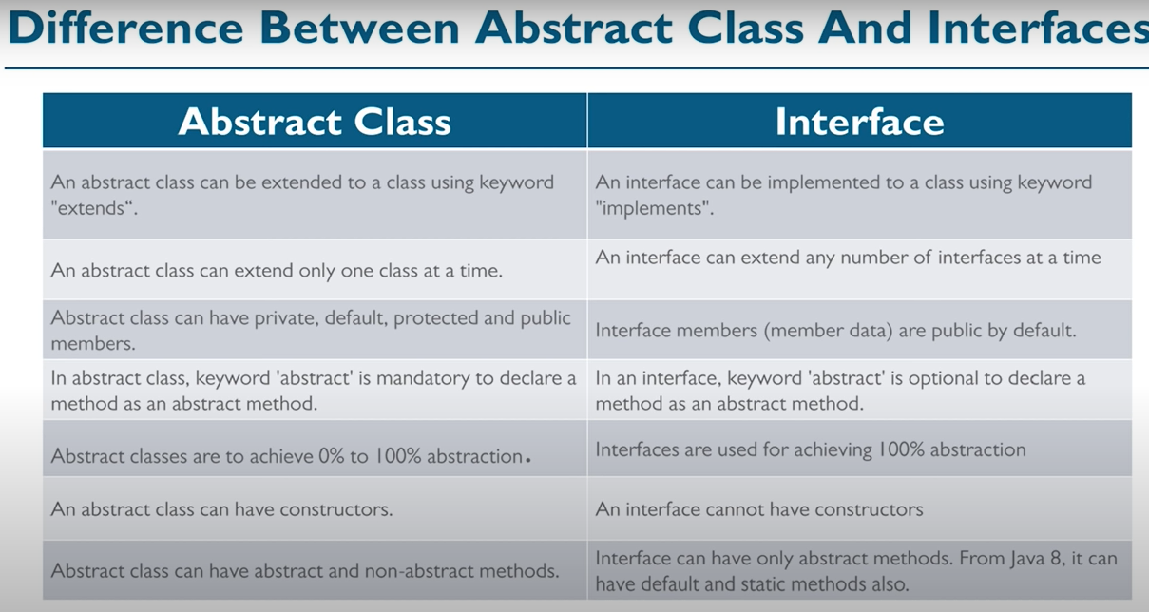

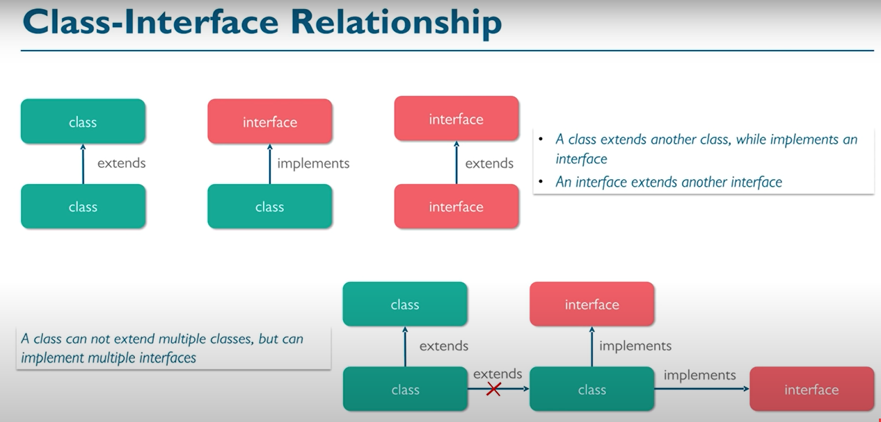

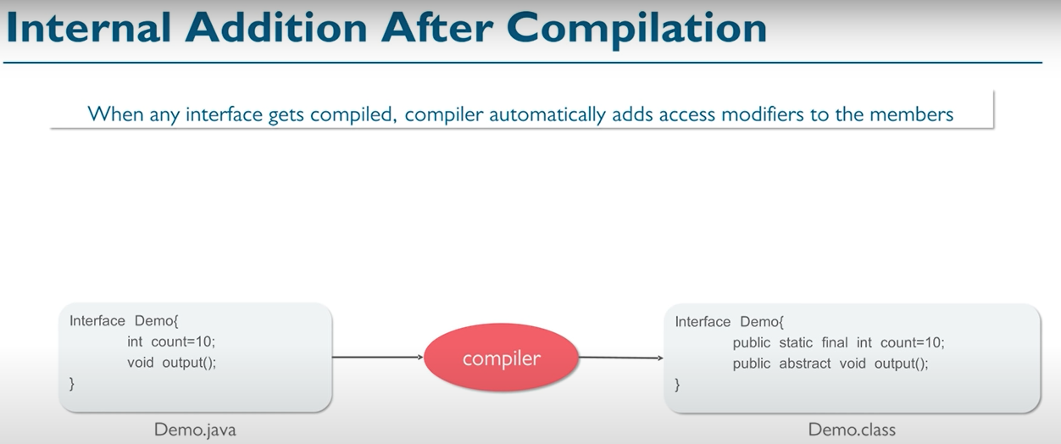

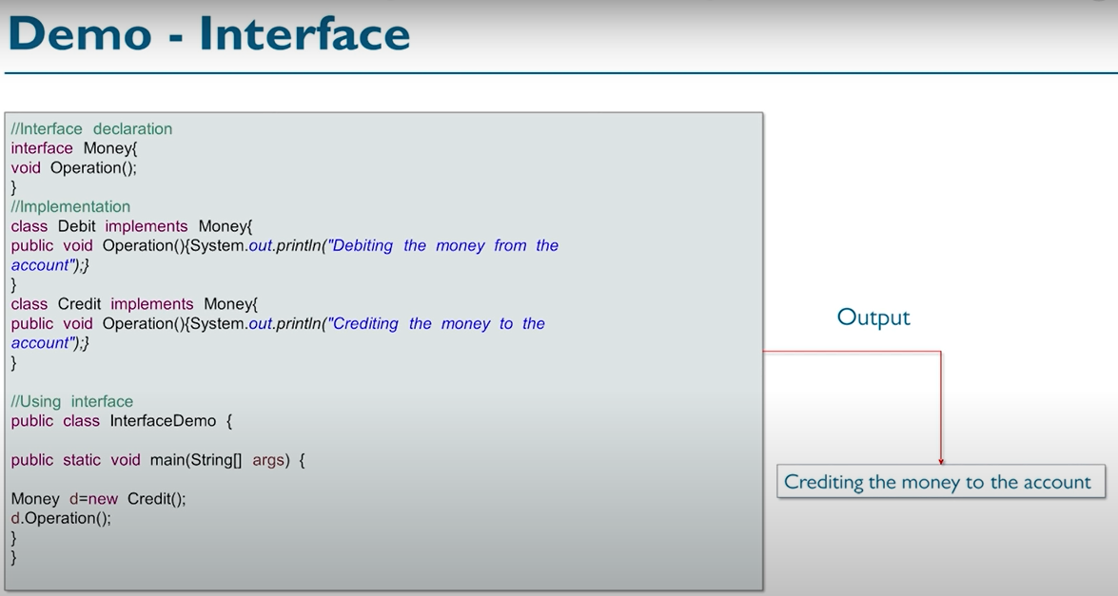

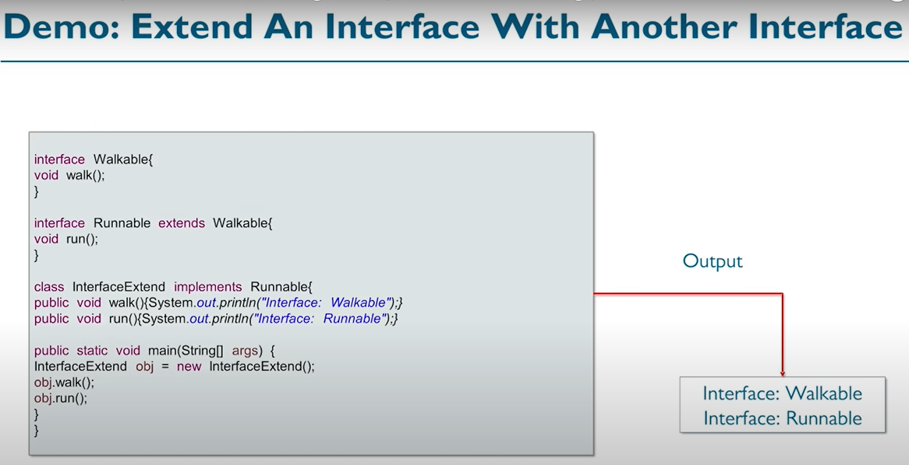

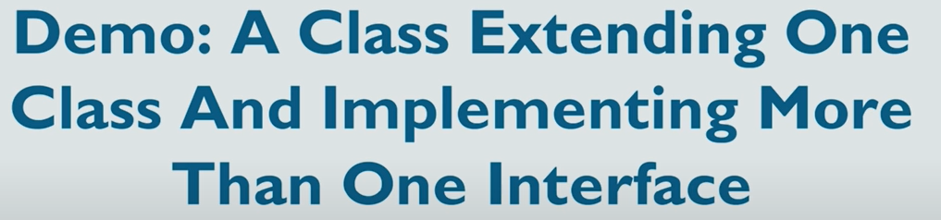

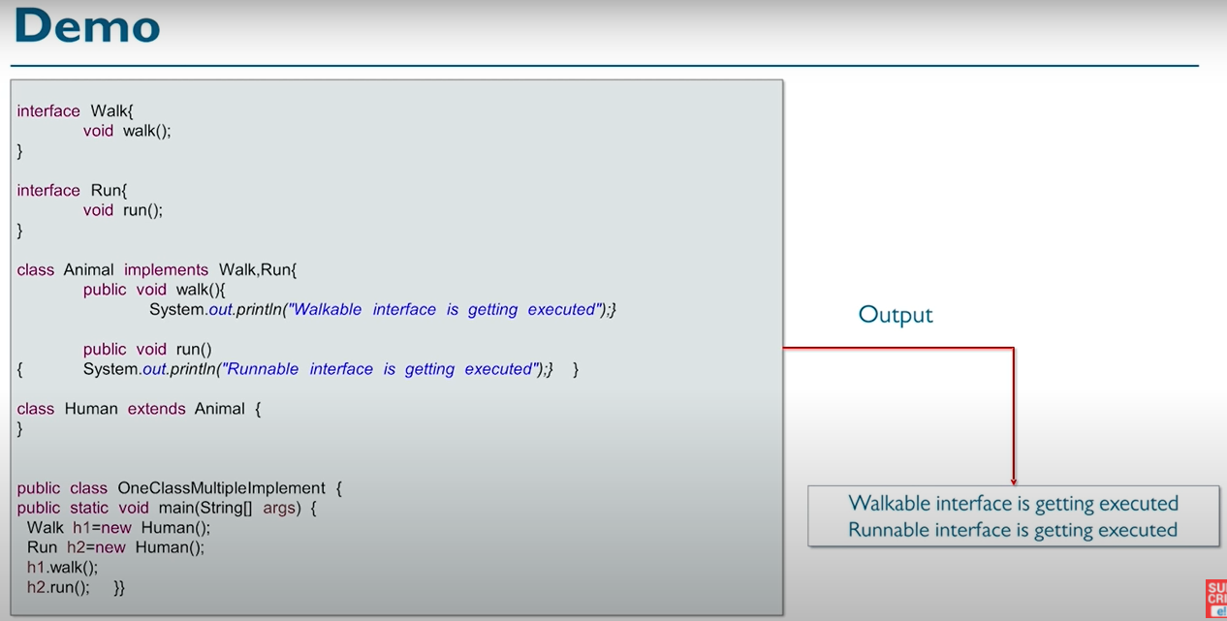

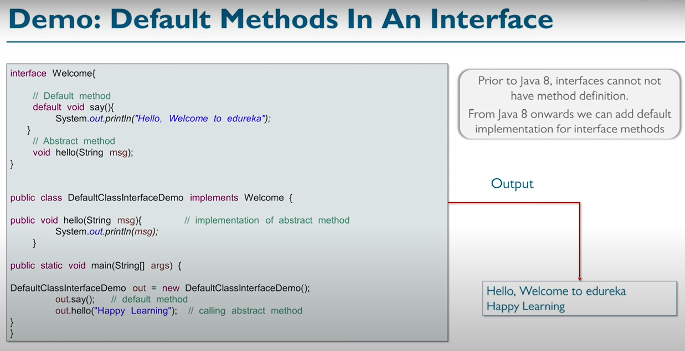

NOTE🡪 Child class implementing the interface cannot override the default method, it can just inherit or call the default method.

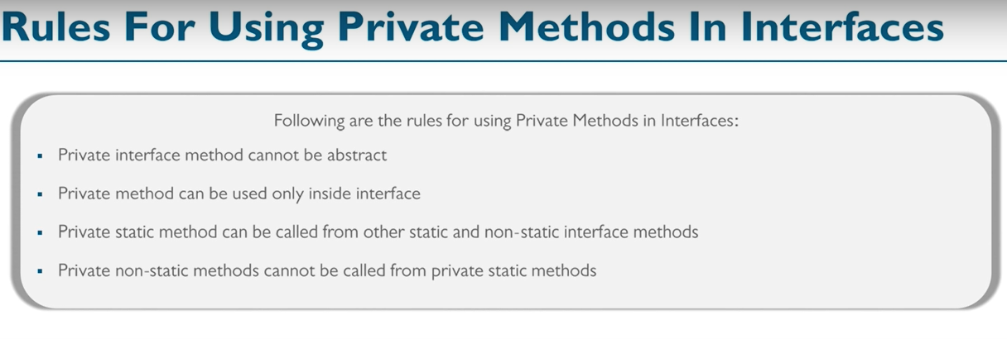

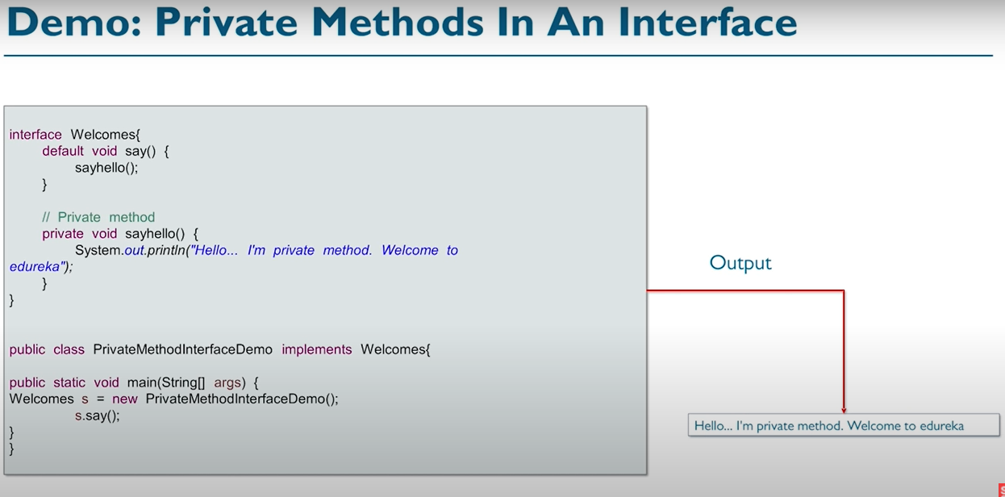

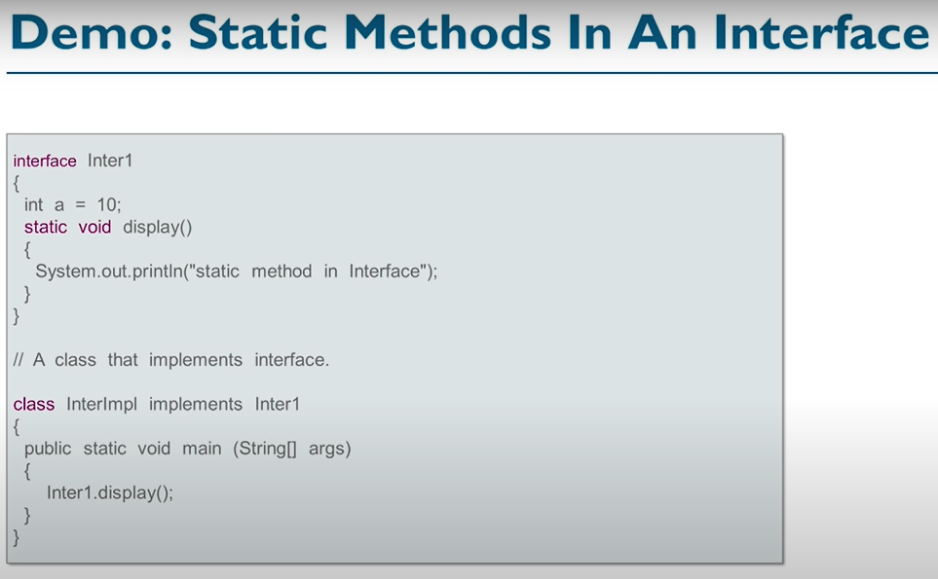

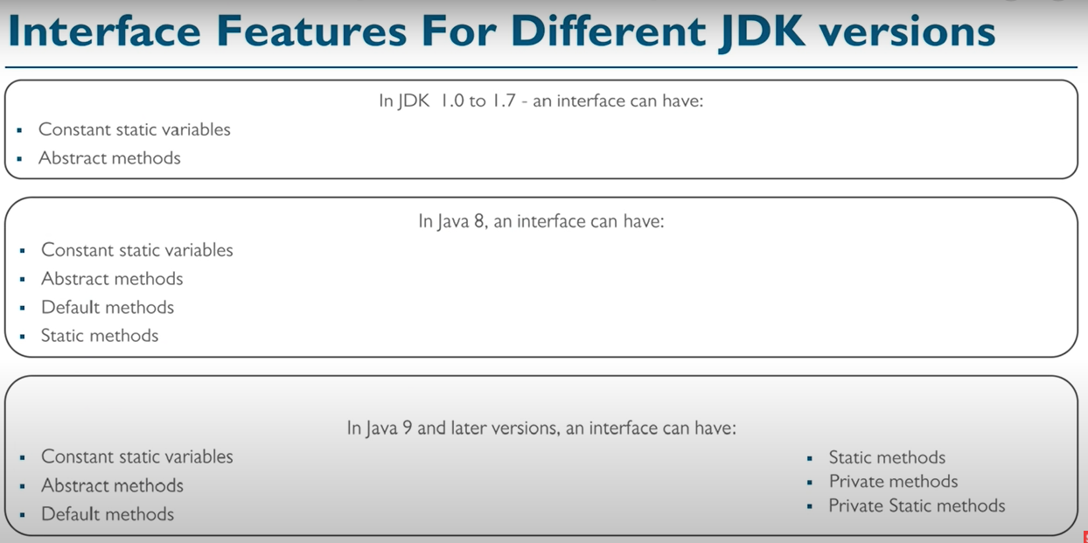

**PACKAGE🡪**

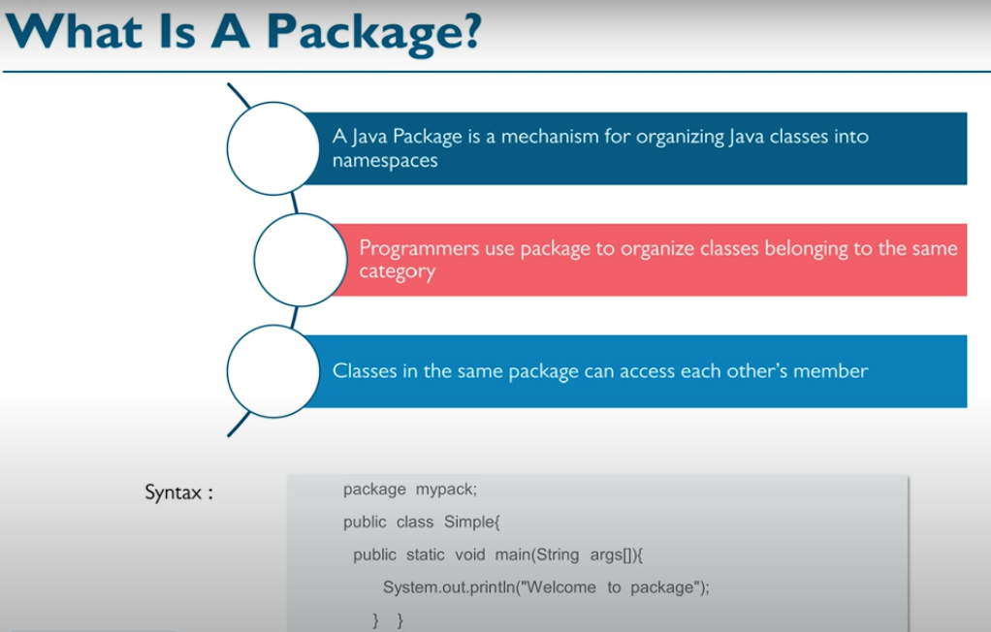

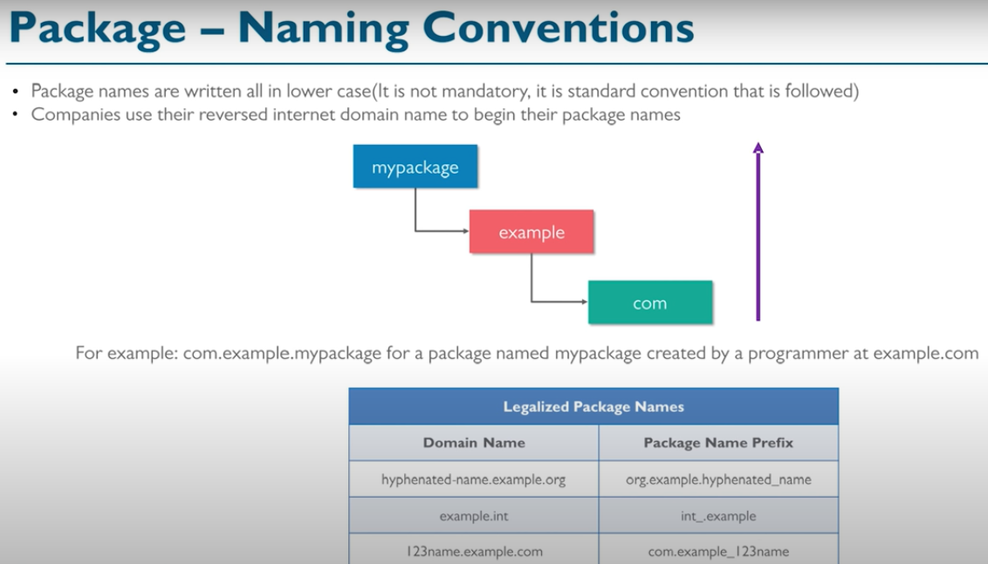

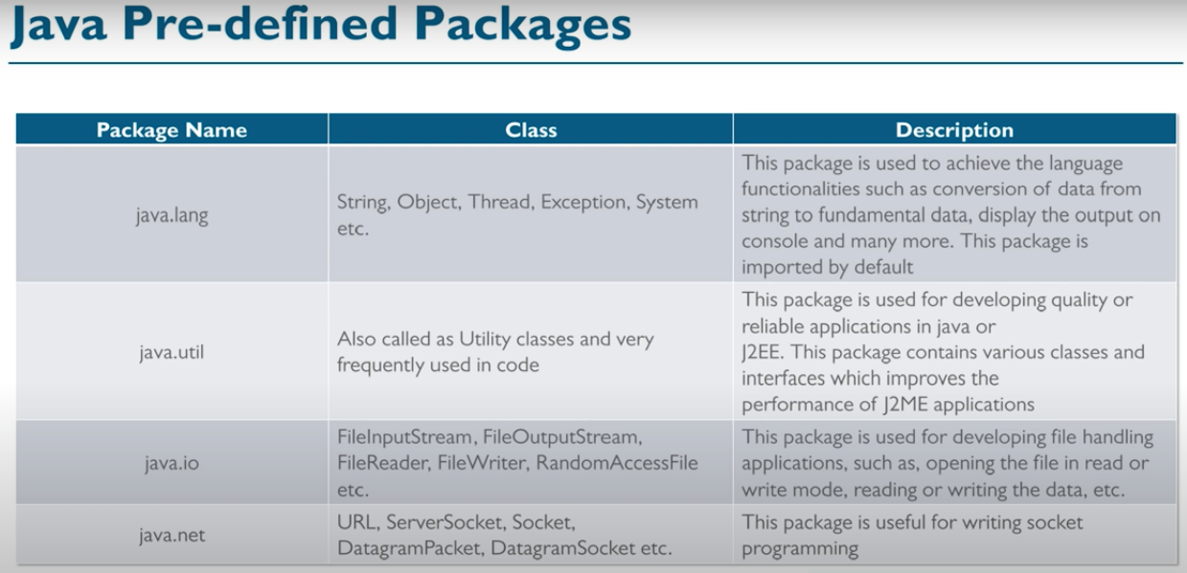

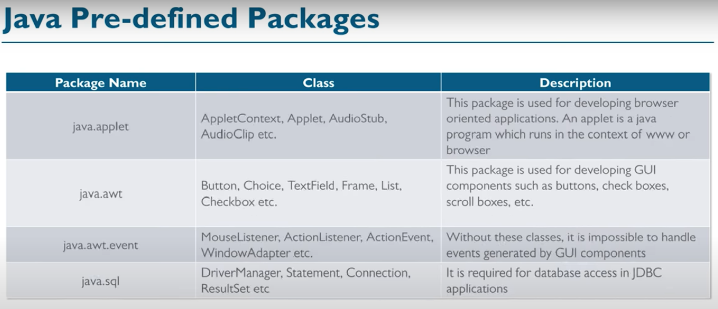

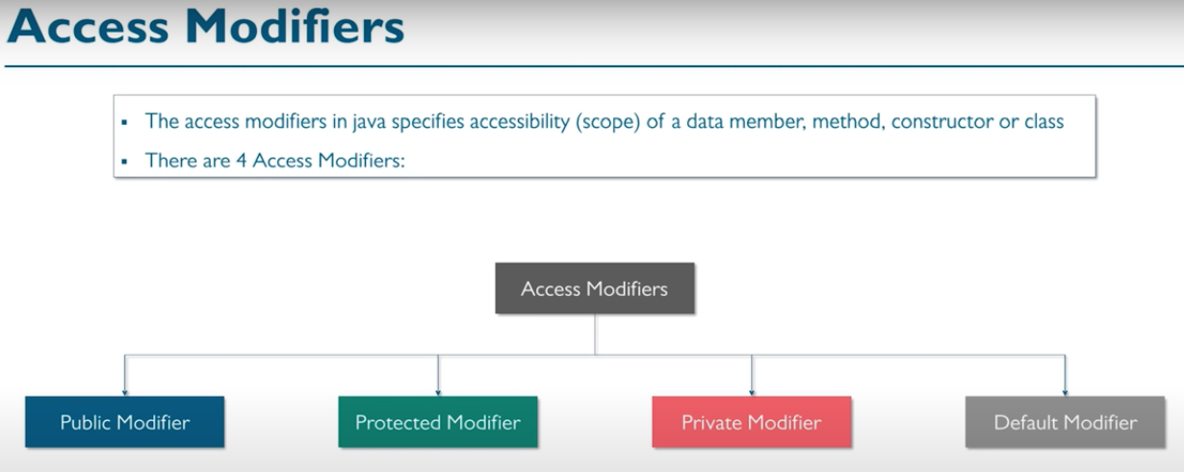

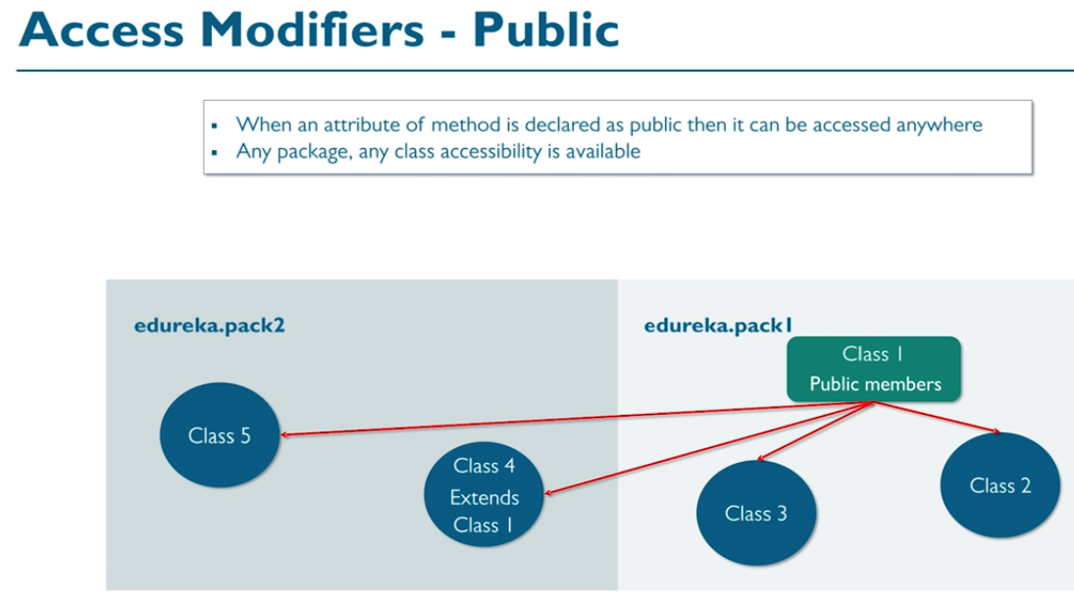

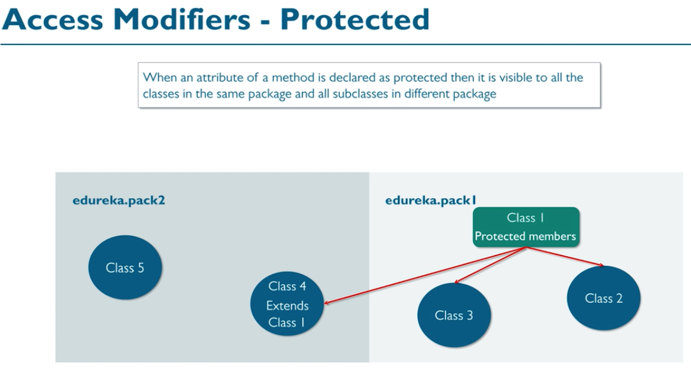

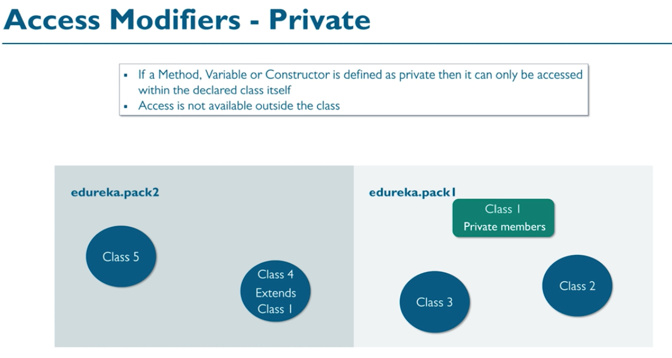

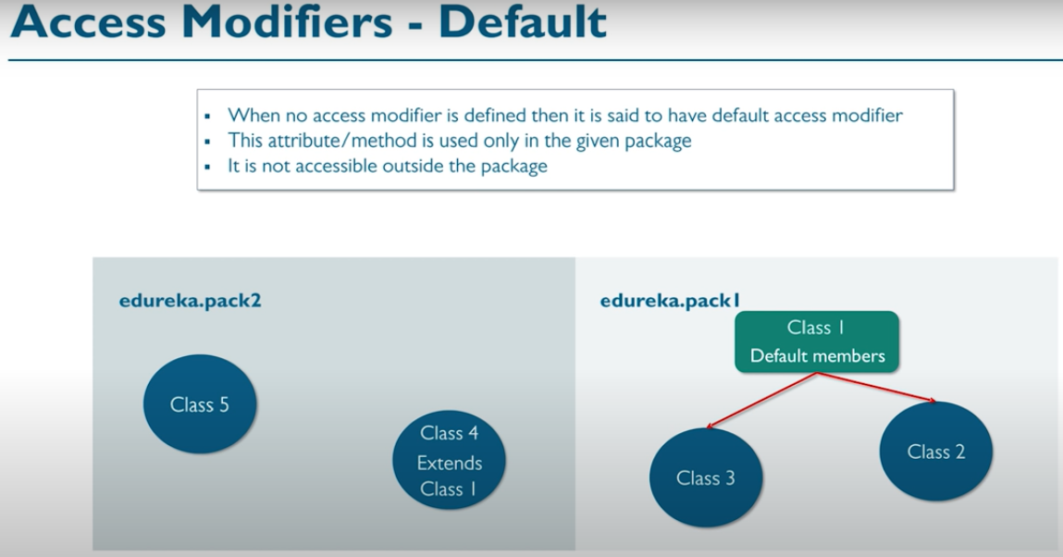

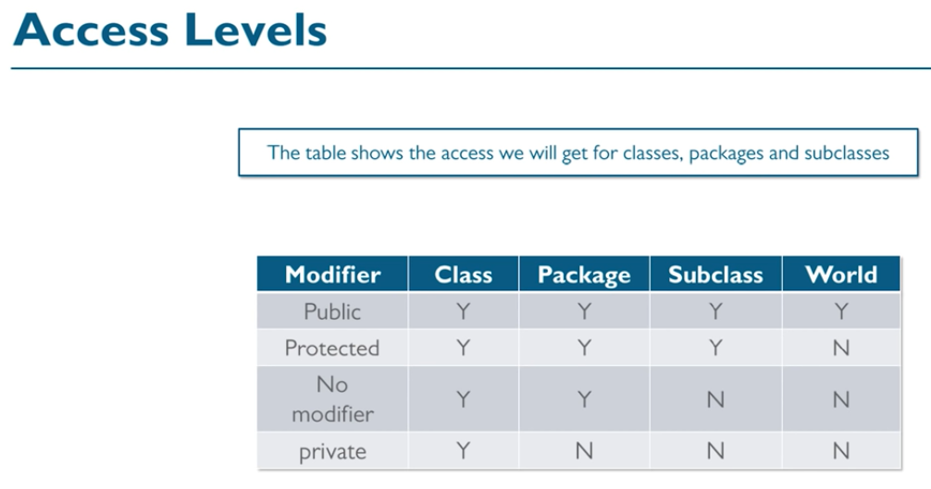

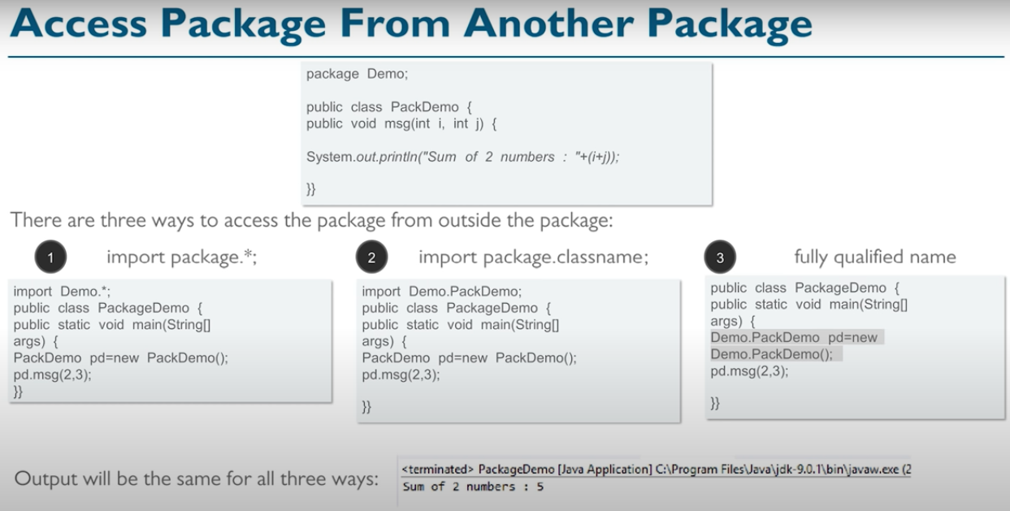

**Regular Expression🡪**

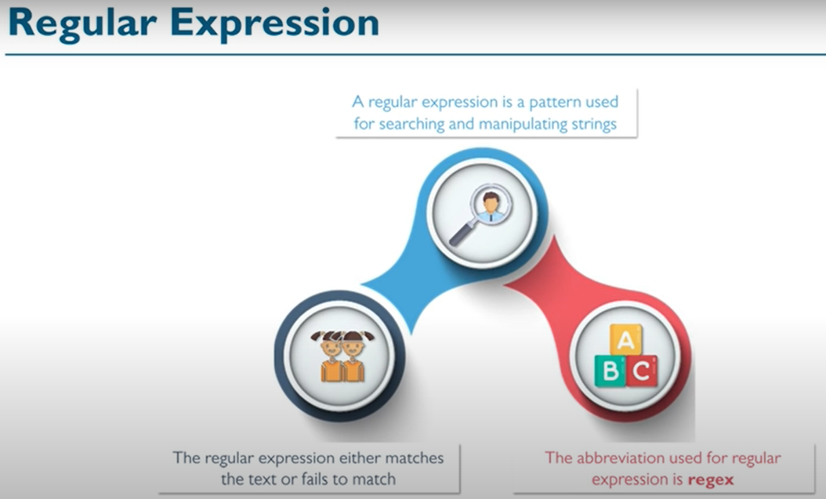

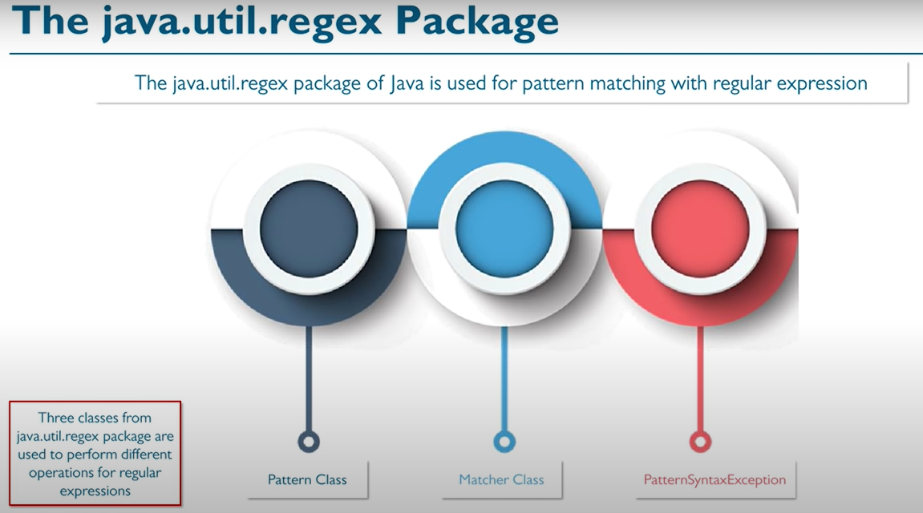

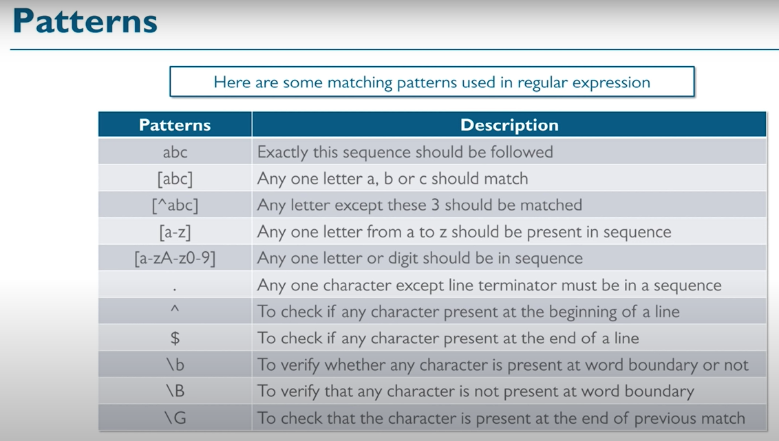

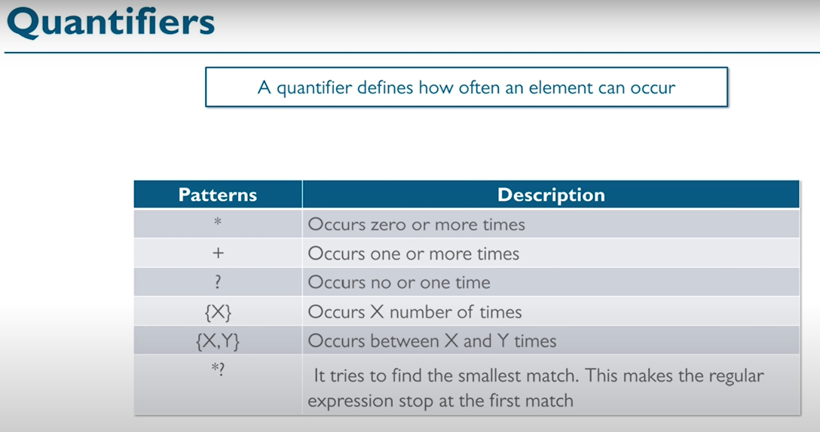

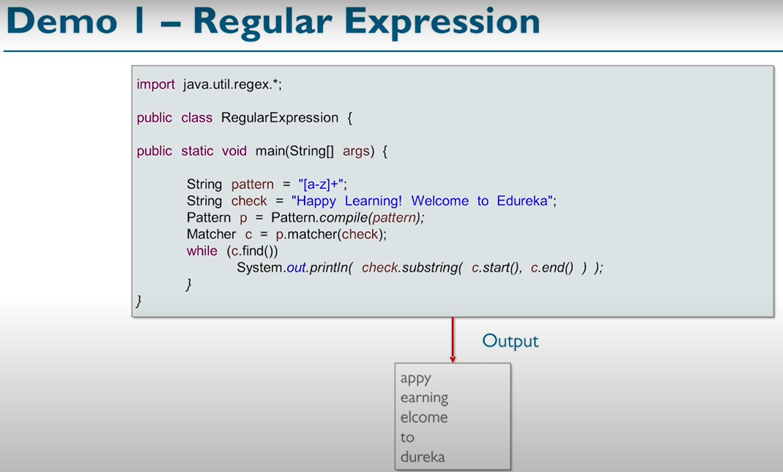

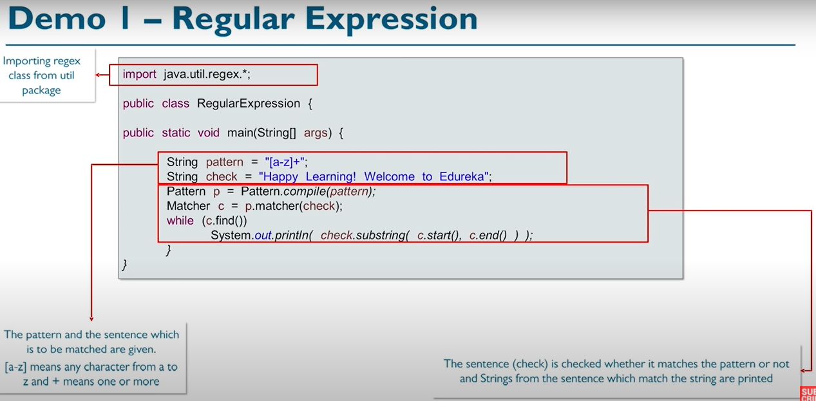

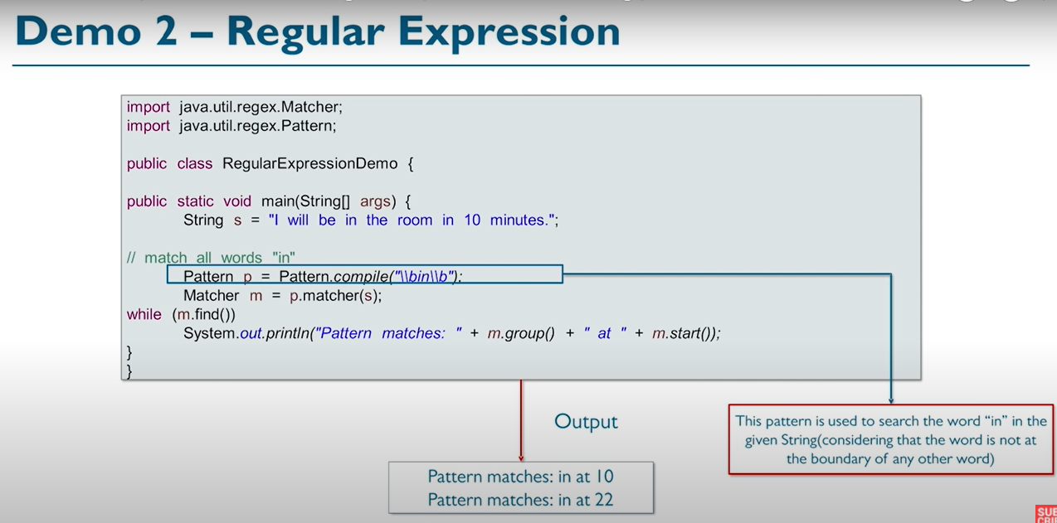

**Exception🡪**

